**AWS Task-5**

**Task Description:**

**Deploy a simple web application using AWS code commit, code build and deploy & access via browser and automate via codepipeline.**

**Steps:**

1. Create an EC2 Server
2. IAM Roles:
   1. EC2
   2. Code Deploy
3. Install Code Deploy agent in the EC2
4. Code in GitHub
5. Create a Code Deploy and Deployment Group
6. Code Build (Optional for simple application)
7. Create the Code Pipeline

**Create an EC2 Server**

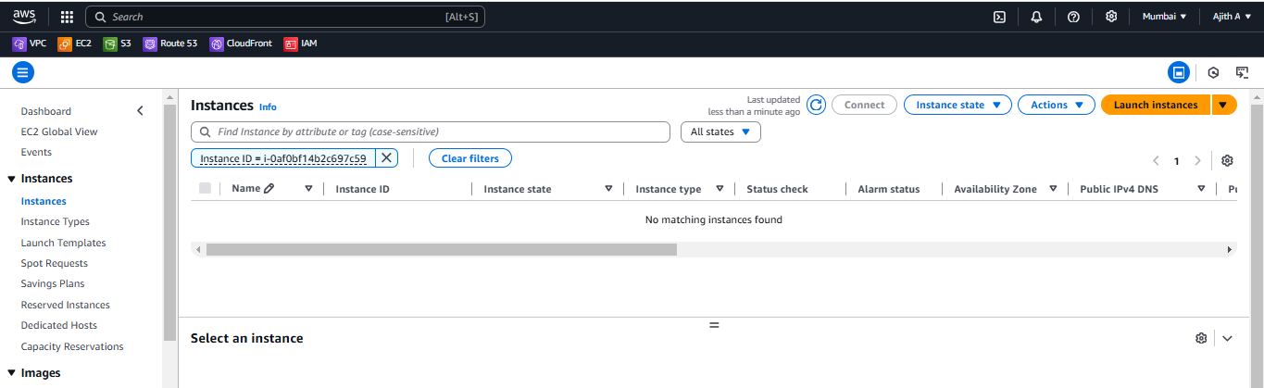

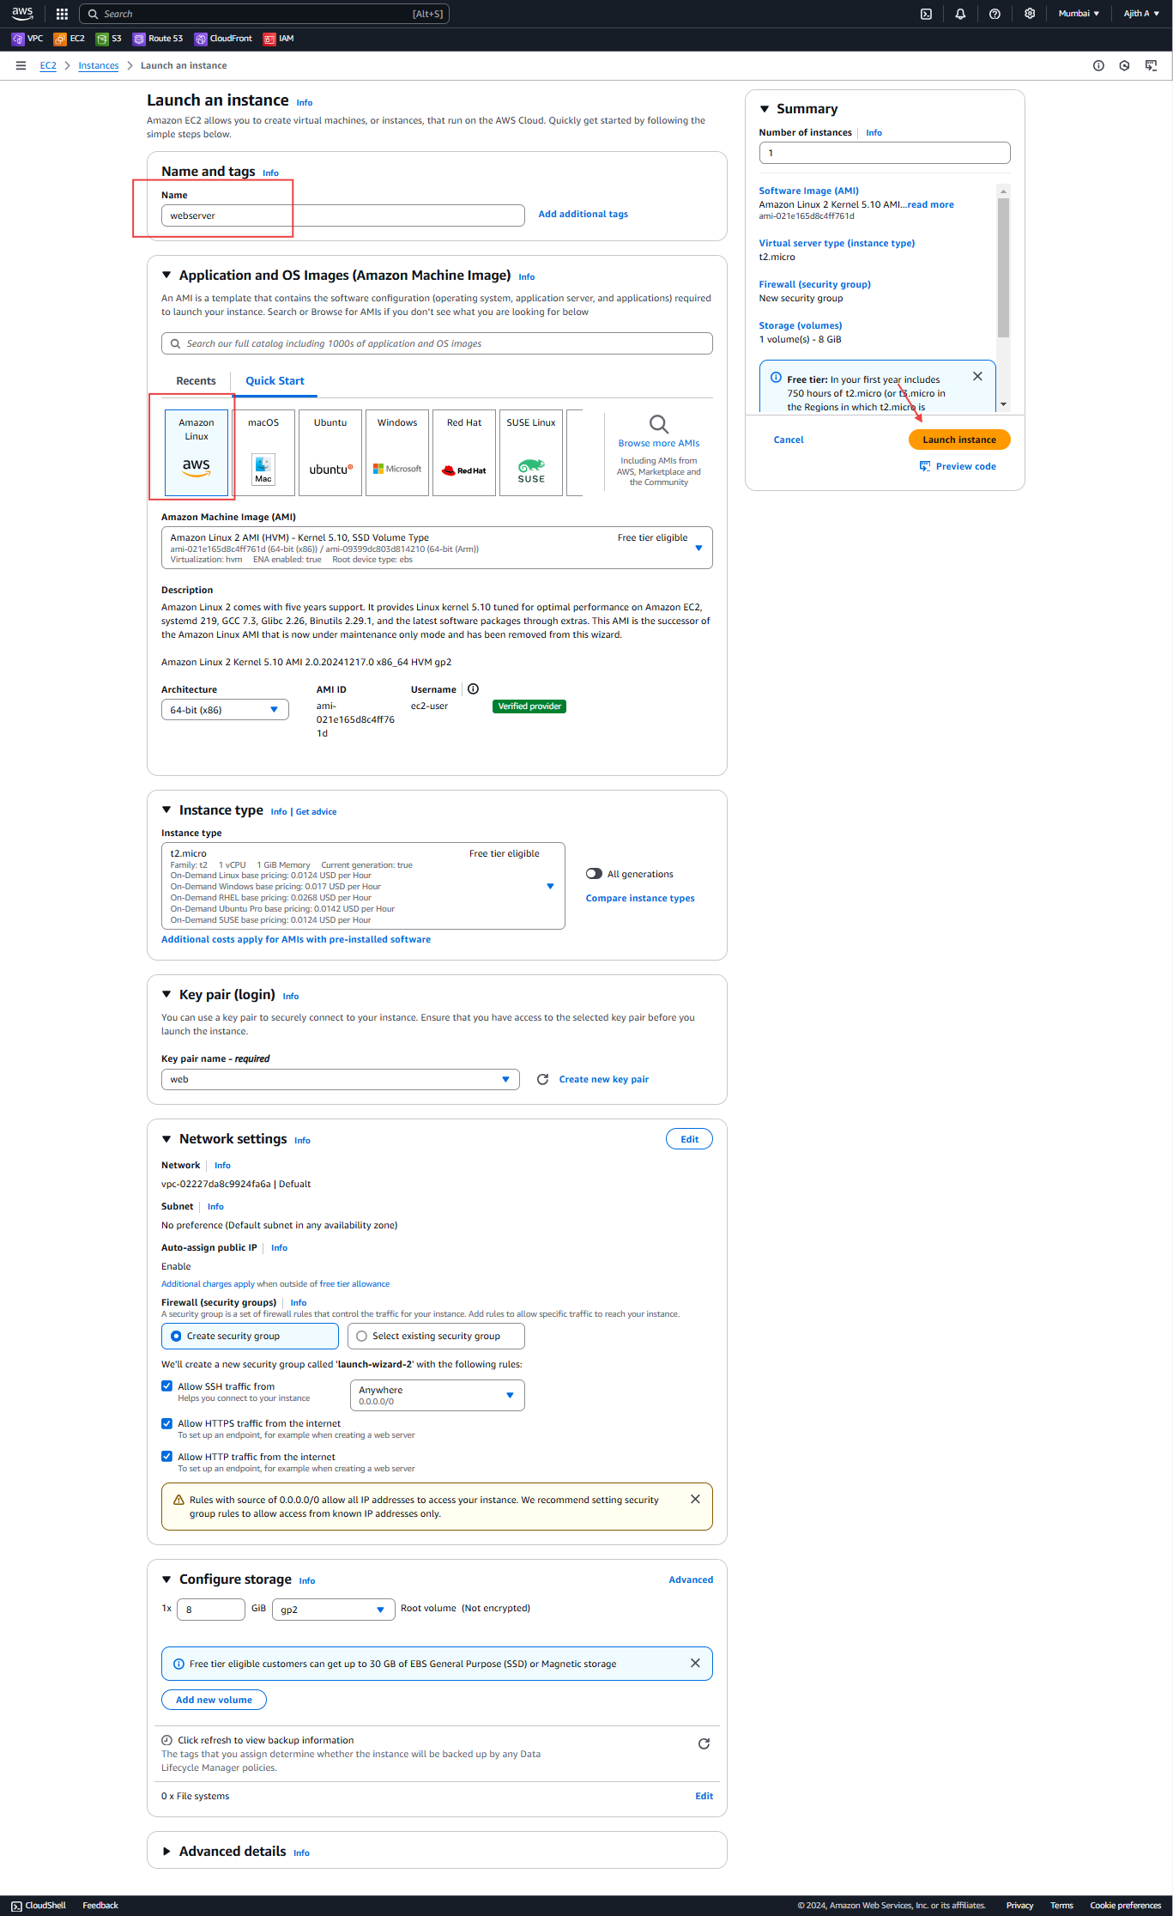

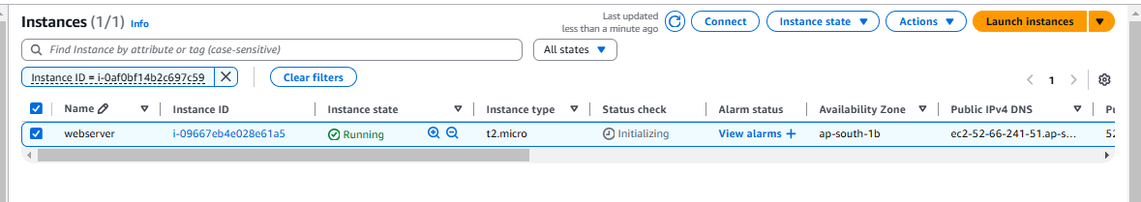

2.IAM Roles:

* 1. EC2,
  2. Code Deploy,
  3. Code in GitHub,

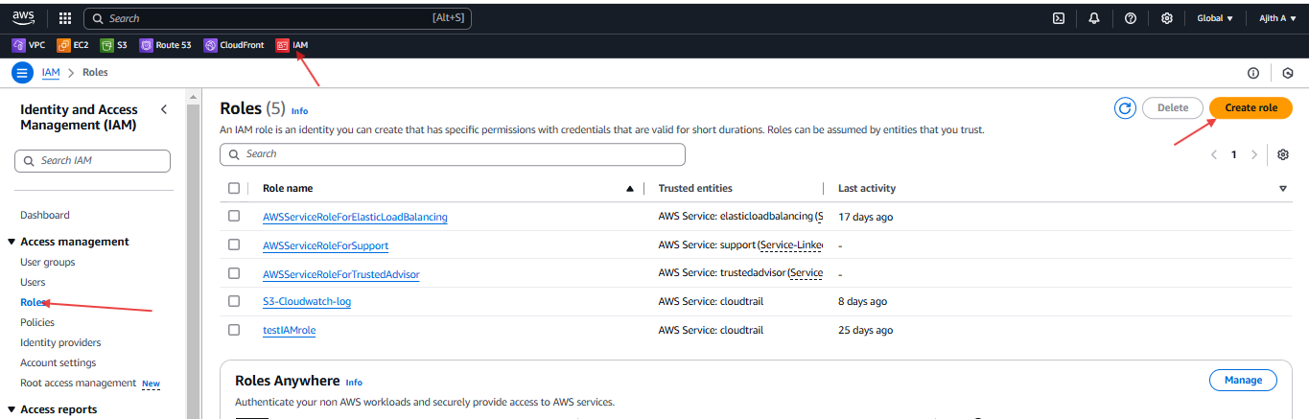

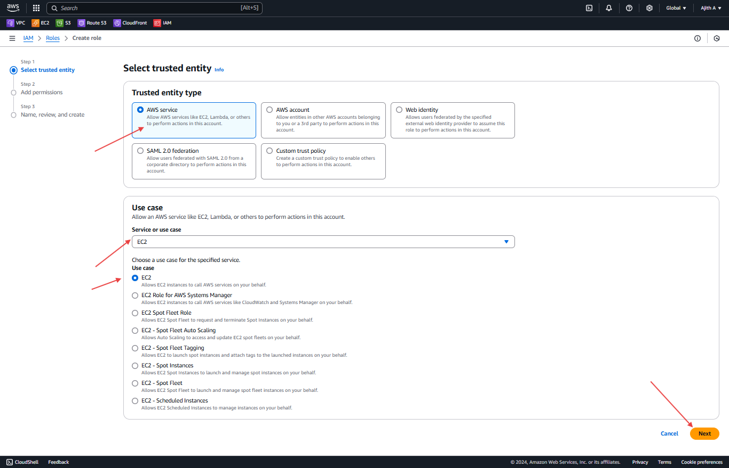

**Role Name : AWSCodeDeployRole**

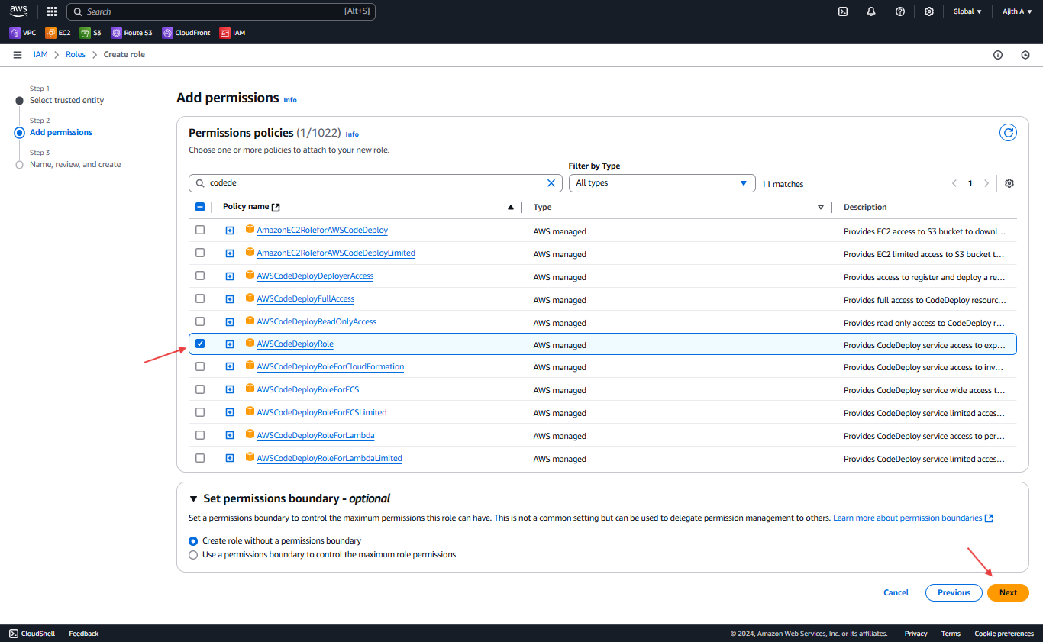

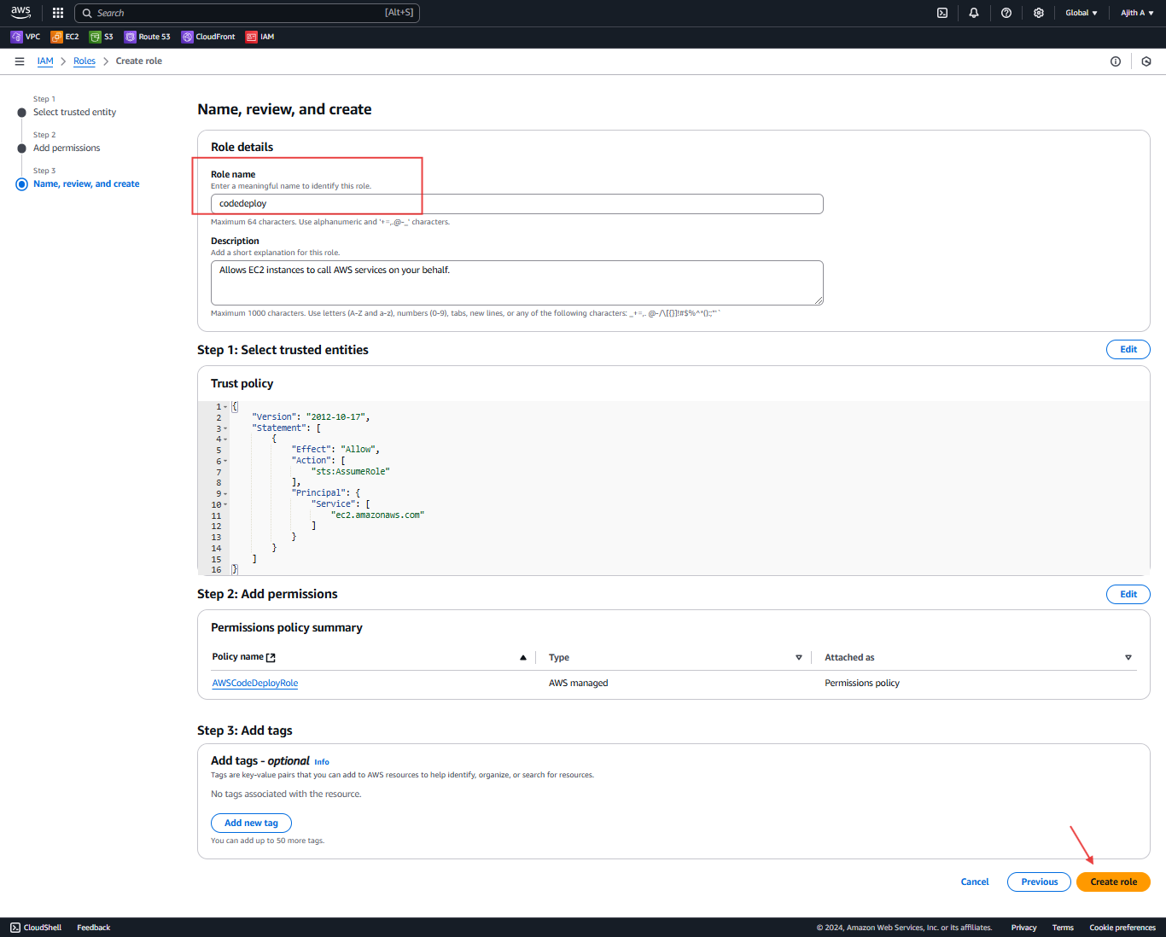

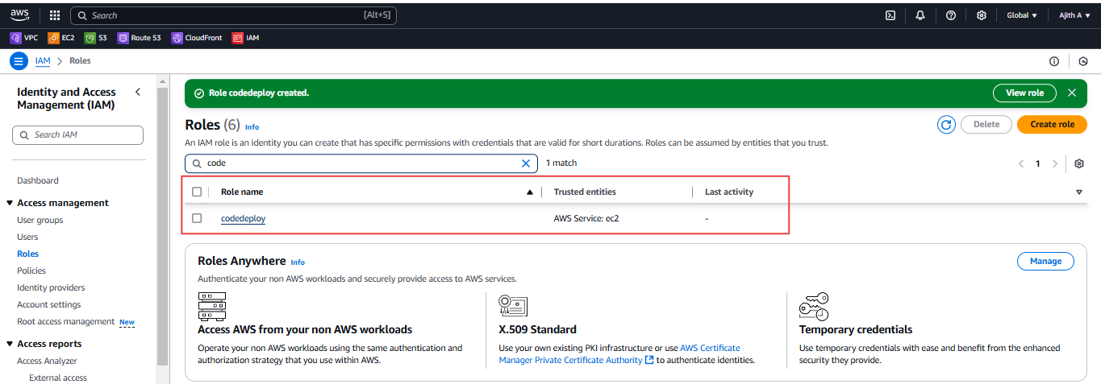

Hear change to "ec2.amazonaws.com" to "[codedeploy](https://us-east-1.console.aws.amazon.com/iam/home?region=ap-south-1" \l "/roles/details/codedeploy).amazonaws.com"

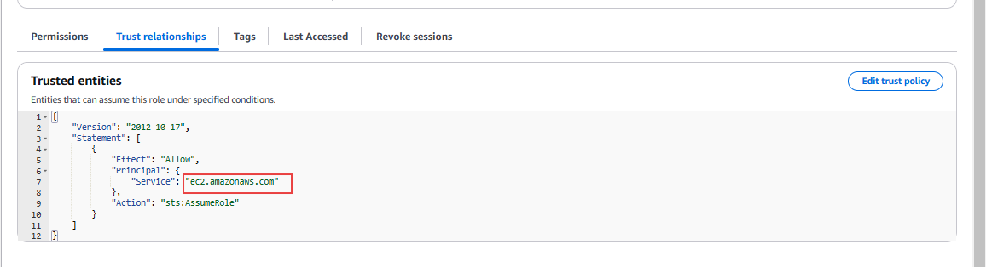

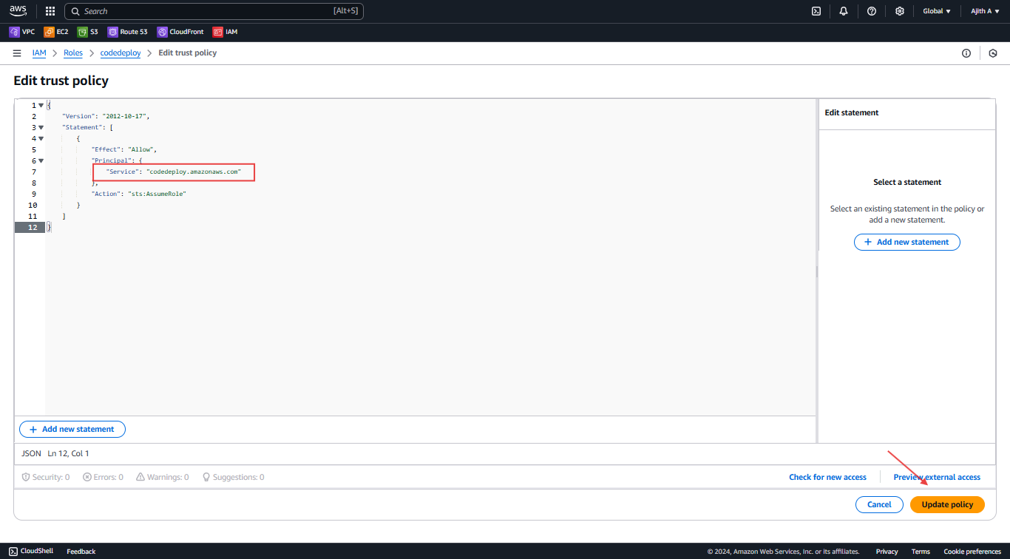

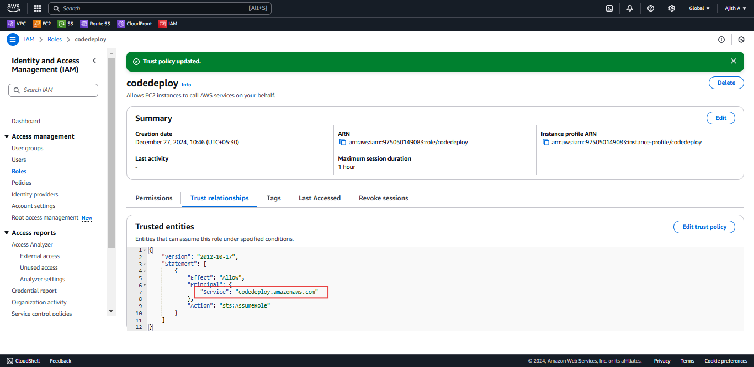

Now Add another role = **Role Name : AWSCodeDeployRole and AmazonS3FullAccess**





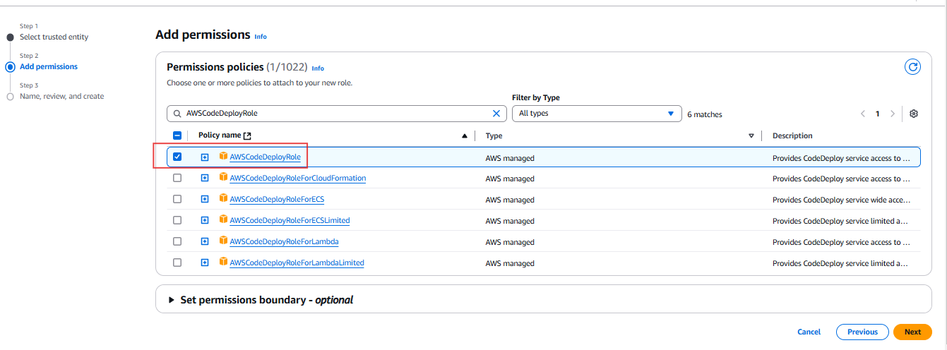

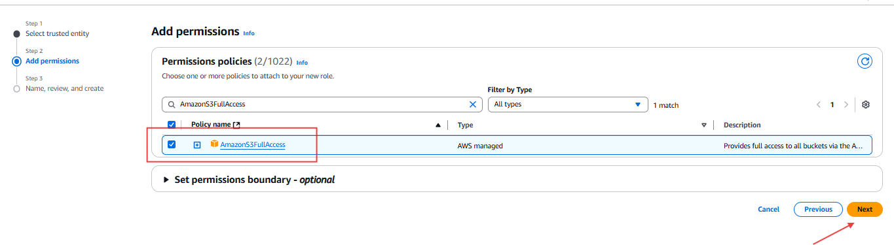

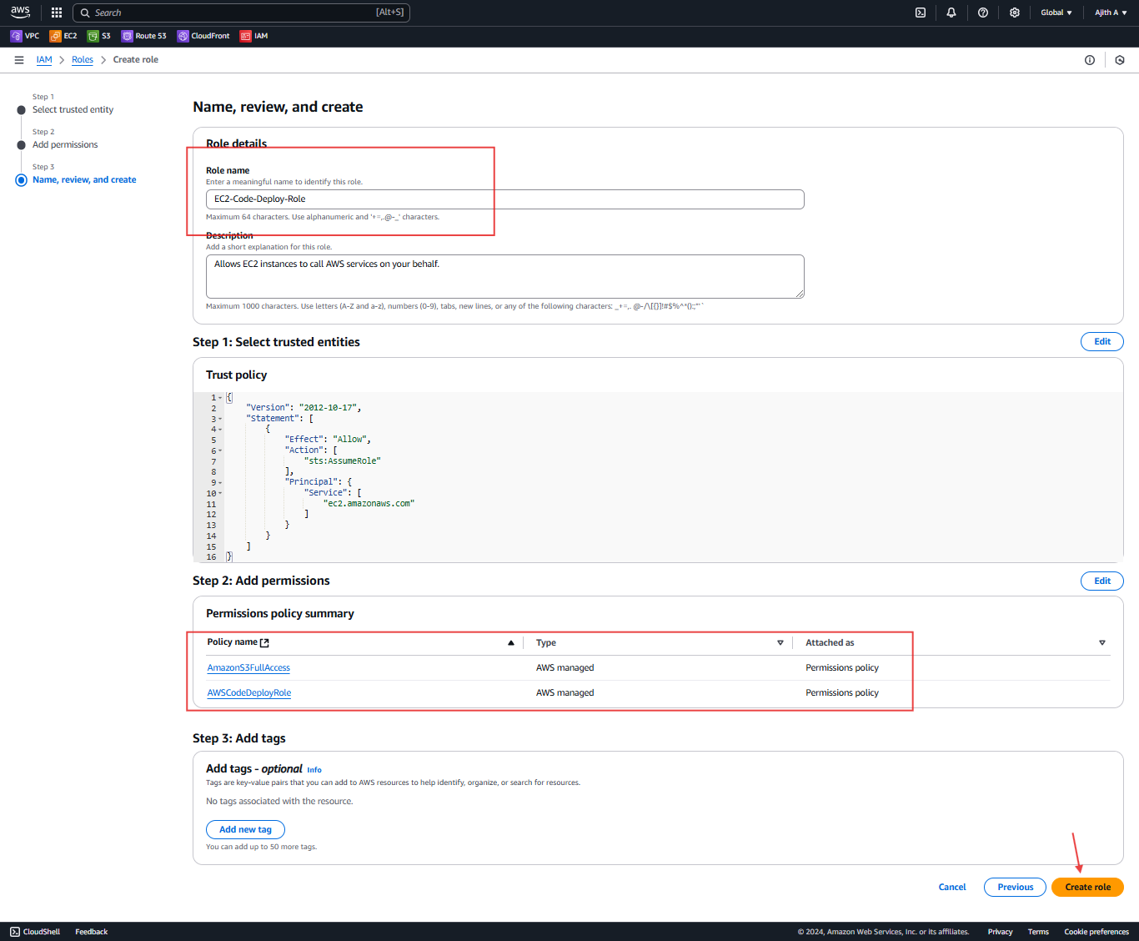

Now going to EC2 Instant and Change IAM role

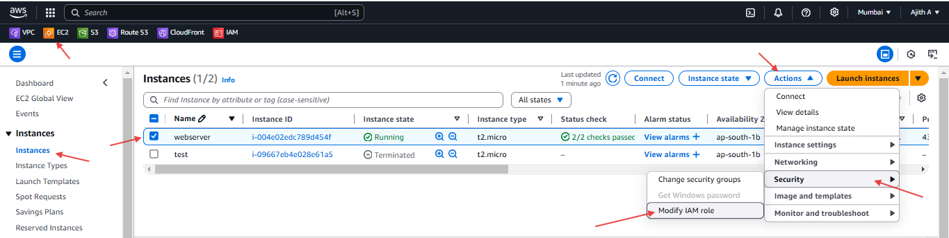

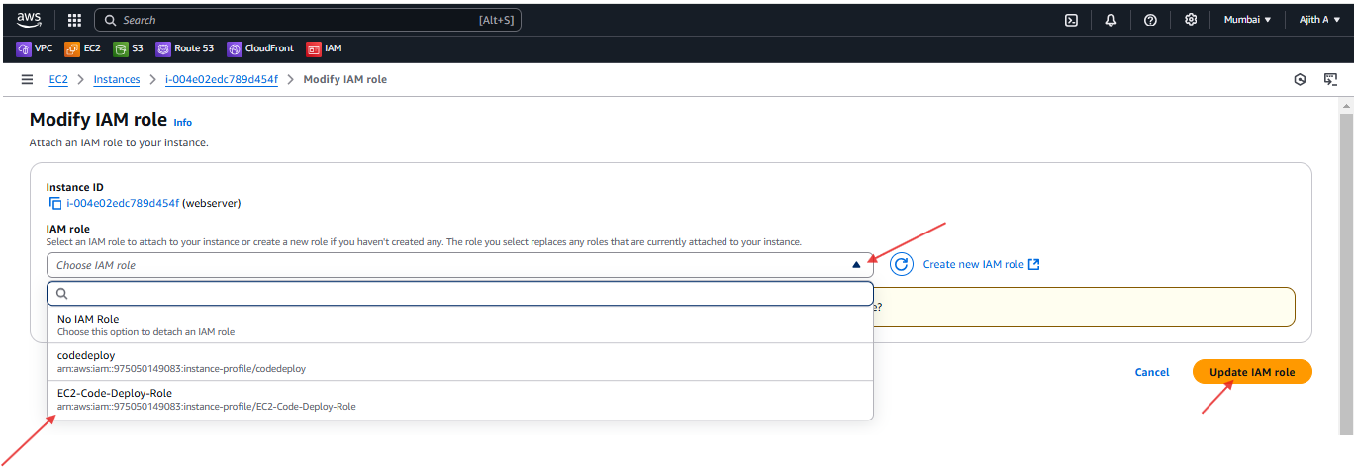

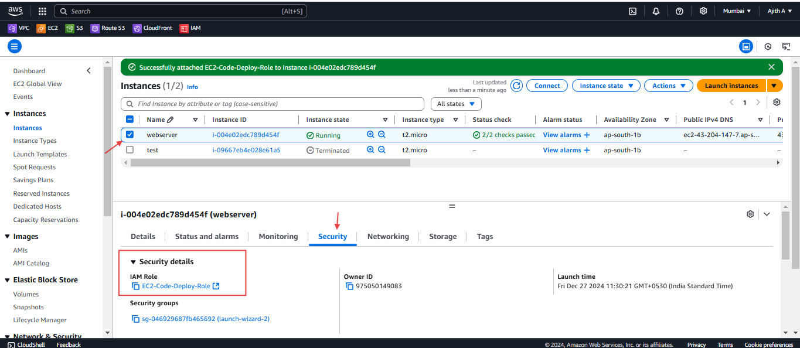

Now ready to EC2 Instance Part

Next Install Code Deploy agent in the EC2

Go to EC2 using command line

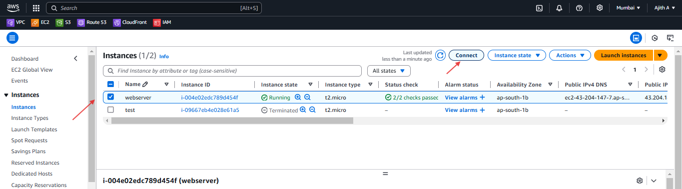

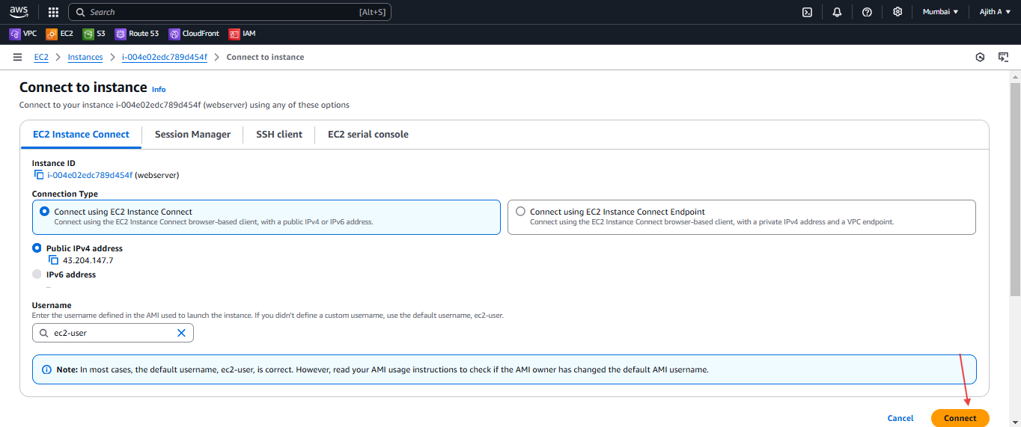

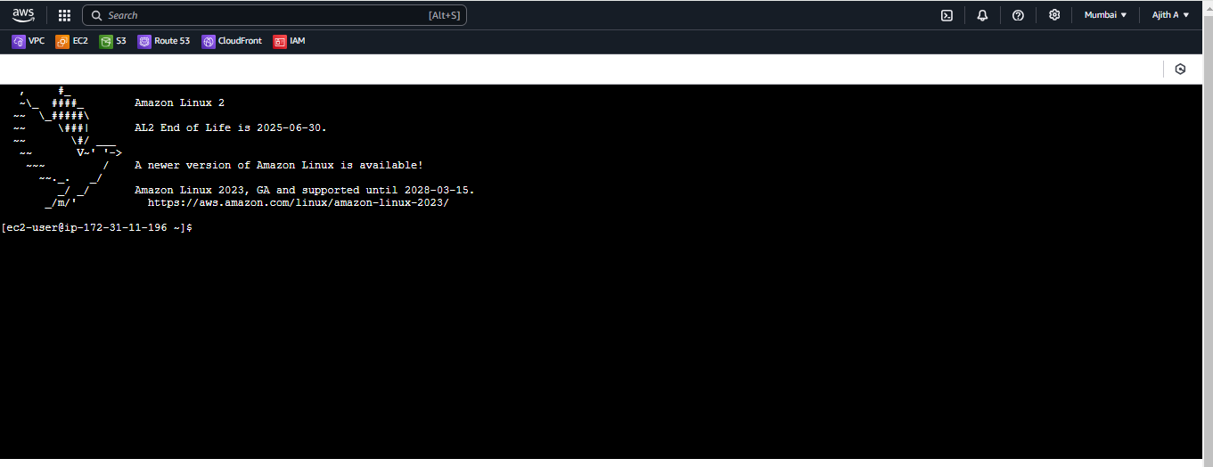

Execute following commands - Code Deploy agent

**Code:**

**sudo yum update -y**

**sudo yum install ruby -y**

**sudo yum install wget -y**

**wget https://aws-codedeploy-us-east-1.s3.amazonaws.com/latest/install**

**chmod +x ./install**

**sudo ./install auto**

**sudo service codedeploy-agent start**

**sudo service codedeploy-agent status**

**Output**

, #_

~\_ ####_ Amazon Linux 2

~~ \_#####\

~~ \###| AL2 End of Life is 2025-06-30.

~~ \#/ ___

~~ V~' '->

~~~ / A newer version of Amazon Linux is available!

~~._. _/

_/ _/ Amazon Linux 2023, GA and supported until 2028-03-15.

_/m/' https://aws.amazon.com/linux/amazon-linux-2023/

[ec2-user@ip-172-31-11-196 ~]$ **sudo yum update -y**

Loaded plugins: extras_suggestions, langpacks, priorities, update-motd

amzn2-core | 3.6 kB 00:00:00

No packages marked for update

[ec2-user@ip-172-31-11-196 ~]$ **sudo yum install ruby -y**

Loaded plugins: extras_suggestions, langpacks, priorities, update-motd

Resolving Dependencies

--> Running transaction check

---> Package ruby.x86_64 0:2.0.0.648-36.amzn2.0.14 will be installed

--> Processing Dependency: ruby-libs(x86-64) = 2.0.0.648-36.amzn2.0.14 for package: ruby-2.0.0.648-36.amzn2.0.14.x86_64

--> Processing Dependency: ruby(rubygems) >= 2.0.14.1 for package: ruby-2.0.0.648-36.amzn2.0.14.x86_64

--> Processing Dependency: rubygem(bigdecimal) >= 1.2.0 for package: ruby-2.0.0.648-36.amzn2.0.14.x86_64

--> Processing Dependency: libruby.so.2.0()(64bit) for package: ruby-2.0.0.648-36.amzn2.0.14.x86_64

--> Running transaction check

---> Package ruby-libs.x86_64 0:2.0.0.648-36.amzn2.0.14 will be installed

---> Package rubygem-bigdecimal.x86_64 0:1.2.0-36.amzn2.0.14 will be installed

---> Package rubygems.noarch 0:2.0.14.1-36.amzn2.0.14 will be installed

--> Processing Dependency: rubygem(io-console) >= 0.4.2 for package: rubygems-2.0.14.1-36.amzn2.0.14.noarch

--> Processing Dependency: rubygem(psych) >= 2.0.0 for package: rubygems-2.0.14.1-36.amzn2.0.14.noarch

--> Processing Dependency: rubygem(rdoc) >= 4.0.0 for package: rubygems-2.0.14.1-36.amzn2.0.14.noarch

--> Running transaction check

---> Package rubygem-io-console.x86_64 0:0.4.2-36.amzn2.0.14 will be installed

---> Package rubygem-psych.x86_64 0:2.0.0-36.amzn2.0.14 will be installed

---> Package rubygem-rdoc.noarch 0:4.0.0-36.amzn2.0.14 will be installed

--> Processing Dependency: ruby(irb) = 2.0.0.648 for package: rubygem-rdoc-4.0.0-36.amzn2.0.14.noarch

--> Processing Dependency: rubygem(json) >= 1.7.7 for package: rubygem-rdoc-4.0.0-36.amzn2.0.14.noarch

--> Running transaction check

---> Package ruby-irb.noarch 0:2.0.0.648-36.amzn2.0.14 will be installed

---> Package rubygem-json.x86_64 0:1.7.7-36.amzn2.0.14 will be installed

--> Finished Dependency Resolution

Dependencies Resolved

=========================================================================================================================================================================================

Package Arch Version Repository Size

=========================================================================================================================================================================================

Installing:

ruby x86_64 2.0.0.648-36.amzn2.0.14 amzn2-core 76 k

Installing for dependencies:

ruby-irb noarch 2.0.0.648-36.amzn2.0.14 amzn2-core 97 k

ruby-libs x86_64 2.0.0.648-36.amzn2.0.14 amzn2-core 2.8 M

rubygem-bigdecimal x86_64 1.2.0-36.amzn2.0.14 amzn2-core 87 k

rubygem-io-console x86_64 0.4.2-36.amzn2.0.14 amzn2-core 59 k

rubygem-json x86_64 1.7.7-36.amzn2.0.14 amzn2-core 84 k

rubygem-psych x86_64 2.0.0-36.amzn2.0.14 amzn2-core 87 k

rubygem-rdoc noarch 4.0.0-36.amzn2.0.14 amzn2-core 327 k

rubygems noarch 2.0.14.1-36.amzn2.0.14 amzn2-core 218 k

Transaction Summary

=========================================================================================================================================================================================

Install 1 Package (+8 Dependent packages)

Total download size: 3.8 M

Installed size: 12 M

Downloading packages:

(1/9): ruby-2.0.0.648-36.amzn2.0.14.x86_64.rpm | 76 kB 00:00:00

(2/9): ruby-irb-2.0.0.648-36.amzn2.0.14.noarch.rpm | 97 kB 00:00:00

(3/9): rubygem-bigdecimal-1.2.0-36.amzn2.0.14.x86_64.rpm | 87 kB 00:00:00

(4/9): ruby-libs-2.0.0.648-36.amzn2.0.14.x86_64.rpm | 2.8 MB 00:00:00

(5/9): rubygem-io-console-0.4.2-36.amzn2.0.14.x86_64.rpm | 59 kB 00:00:00

(6/9): rubygem-psych-2.0.0-36.amzn2.0.14.x86_64.rpm | 87 kB 00:00:00

(7/9): rubygem-json-1.7.7-36.amzn2.0.14.x86_64.rpm | 84 kB 00:00:00

(8/9): rubygem-rdoc-4.0.0-36.amzn2.0.14.noarch.rpm | 327 kB 00:00:00

(9/9): rubygems-2.0.14.1-36.amzn2.0.14.noarch.rpm | 218 kB 00:00:00

-----------------------------------------------------------------------------------------------------------------------------------------------------------------------------------------

Total 14 MB/s | 3.8 MB 00:00:00

Running transaction check

Running transaction test

Transaction test succeeded

Running transaction

Installing : ruby-libs-2.0.0.648-36.amzn2.0.14.x86_64 1/9

Installing : ruby-irb-2.0.0.648-36.amzn2.0.14.noarch 2/9

Installing : rubygem-json-1.7.7-36.amzn2.0.14.x86_64 3/9

Installing : rubygem-io-console-0.4.2-36.amzn2.0.14.x86_64 4/9

Installing : rubygem-psych-2.0.0-36.amzn2.0.14.x86_64 5/9

Installing : rubygem-bigdecimal-1.2.0-36.amzn2.0.14.x86_64 6/9

Installing : rubygems-2.0.14.1-36.amzn2.0.14.noarch 7/9

Installing : ruby-2.0.0.648-36.amzn2.0.14.x86_64 8/9

Installing : rubygem-rdoc-4.0.0-36.amzn2.0.14.noarch 9/9

Verifying : ruby-2.0.0.648-36.amzn2.0.14.x86_64 1/9

Verifying : rubygem-json-1.7.7-36.amzn2.0.14.x86_64 2/9

Verifying : rubygem-io-console-0.4.2-36.amzn2.0.14.x86_64 3/9

Verifying : ruby-libs-2.0.0.648-36.amzn2.0.14.x86_64 4/9

Verifying : rubygems-2.0.14.1-36.amzn2.0.14.noarch 5/9

Verifying : rubygem-psych-2.0.0-36.amzn2.0.14.x86_64 6/9

Verifying : rubygem-bigdecimal-1.2.0-36.amzn2.0.14.x86_64 7/9

Verifying : ruby-irb-2.0.0.648-36.amzn2.0.14.noarch 8/9

Verifying : rubygem-rdoc-4.0.0-36.amzn2.0.14.noarch 9/9

Installed:

ruby.x86_64 0:2.0.0.648-36.amzn2.0.14

Dependency Installed:

ruby-irb.noarch 0:2.0.0.648-36.amzn2.0.14 ruby-libs.x86_64 0:2.0.0.648-36.amzn2.0.14 rubygem-bigdecimal.x86_64 0:1.2.0-36.amzn2.0.14 rubygem-io-console.x86_64 0:0.4.2-36.amzn2.0.14

rubygem-json.x86_64 0:1.7.7-36.amzn2.0.14 rubygem-psych.x86_64 0:2.0.0-36.amzn2.0.14 rubygem-rdoc.noarch 0:4.0.0-36.amzn2.0.14 rubygems.noarch 0:2.0.14.1-36.amzn2.0.14

Complete!

[ec2-user@ip-172-31-11-196 ~]$ **sudo yum install wget -y**

Loaded plugins: extras_suggestions, langpacks, priorities, update-motd

Package wget-1.14-18.amzn2.1.x86_64 already installed and latest version

Nothing to do

[ec2-user@ip-172-31-11-196 ~]$ **wget https://aws-codedeploy-us-east-1.s3.amazonaws.com/latest/install**

--2024-12-27 06:48:41-- https://aws-codedeploy-us-east-1.s3.amazonaws.com/latest/install

Resolving aws-codedeploy-us-east-1.s3.amazonaws.com (aws-codedeploy-us-east-1.s3.amazonaws.com)... 54.231.133.97, 54.231.228.169, 3.5.28.217, ...

Connecting to aws-codedeploy-us-east-1.s3.amazonaws.com (aws-codedeploy-us-east-1.s3.amazonaws.com)|54.231.133.97|:443... connected.

HTTP request sent, awaiting response... 200 OK

Length: 19045 (19K) []

Saving to: ‘install’

100%[===============================================================================================================================================>] 19,045 --.-K/s in 0.001s

2024-12-27 06:48:42 (28.5 MB/s) - ‘install’ saved [19045/19045]

[ec2-user@ip-172-31-11-196 ~]$ **chmod +x ./install**

[ec2-user@ip-172-31-11-196 ~]$ **sudo ./install auto**

I, [2024-12-27T06:51:18.930694 #3974] INFO -- : Starting Ruby version check.

I, [2024-12-27T06:51:18.930932 #3974] INFO -- : Starting update check.

I, [2024-12-27T06:51:18.931067 #3974] INFO -- : Attempting to automatically detect supported package manager type for system...

I, [2024-12-27T06:51:18.940912 #3974] INFO -- : Checking AWS_REGION environment variable for region information...

I, [2024-12-27T06:51:18.940974 #3974] INFO -- : Checking EC2 metadata service for region information...

I, [2024-12-27T06:51:18.952814 #3974] INFO -- : Checking AWS_DOMAIN environment variable for domain information...

I, [2024-12-27T06:51:18.952881 #3974] INFO -- : Checking EC2 metadata service for domain information...

I, [2024-12-27T06:51:18.957925 #3974] INFO -- : Downloading version file from bucket aws-codedeploy-ap-south-1 and key latest/LATEST_VERSION...

I, [2024-12-27T06:51:18.958334 #3974] INFO -- : Endpoint: https://aws-codedeploy-ap-south-1.s3.ap-south-1.amazonaws.com/latest/LATEST_VERSION

I, [2024-12-27T06:51:19.021500 #3974] INFO -- : Downloading package from bucket aws-codedeploy-ap-south-1 and key releases/codedeploy-agent-1.7.1-110.noarch.rpm...

I, [2024-12-27T06:51:19.021712 #3974] INFO -- : Endpoint: https://aws-codedeploy-ap-south-1.s3.ap-south-1.amazonaws.com/releases/codedeploy-agent-1.7.1-110.noarch.rpm

I, [2024-12-27T06:51:19.083978 #3974] INFO -- : Executing `/usr/bin/yum -y localinstall /tmp/codedeploy-agent-1.7.1-110.noarch.tmp-20241227-3974-18fxnk8.rpm`...

Loaded plugins: extras_suggestions, langpacks, priorities, update-motd

Examining /tmp/codedeploy-agent-1.7.1-110.noarch.tmp-20241227-3974-18fxnk8.rpm: codedeploy-agent-1.7.1-110.noarch

Marking /tmp/codedeploy-agent-1.7.1-110.noarch.tmp-20241227-3974-18fxnk8.rpm to be installed

Resolving Dependencies

--> Running transaction check

---> Package codedeploy-agent.noarch 0:1.7.1-110 will be installed

--> Finished Dependency Resolution

Dependencies Resolved

=========================================================================================================================================================================================

Package Arch Version Repository Size

=========================================================================================================================================================================================

Installing:

codedeploy-agent noarch 1.7.1-110 /codedeploy-agent-1.7.1-110.noarch.tmp-20241227-3974-18fxnk8 13 M

Transaction Summary

=========================================================================================================================================================================================

Install 1 Package

Total size: 13 M

Installed size: 13 M

Downloading packages:

Running transaction check

Running transaction test

Transaction test succeeded

Running transaction

pre hook : 1

Checking if there is already a process named codedeploy-agent running.

Installing : codedeploy-agent-1.7.1-110.noarch 1/1

post hook : 1

Check if there is a codedeployagent config file.

Start codedeploy-agent in post hook if this is a first install.

Verifying : codedeploy-agent-1.7.1-110.noarch 1/1

Installed:

codedeploy-agent.noarch 0:1.7.1-110

Complete!

I, [2024-12-27T06:51:21.393129 #3974] INFO -- : Update check complete.

I, [2024-12-27T06:51:21.393194 #3974] INFO -- : Stopping updater.

[ec2-user@ip-172-31-11-196 ~]$ s**udo service codedeploy-agent start**

Starting codedeploy-agent:[ec2-user@ip-172-31-11-196 ~]$ **sudo service codedeploy-agent status**

**The AWS CodeDeploy agent is running as PID 4052**

**Next Code in GitHub**

**Now got to GitHub**

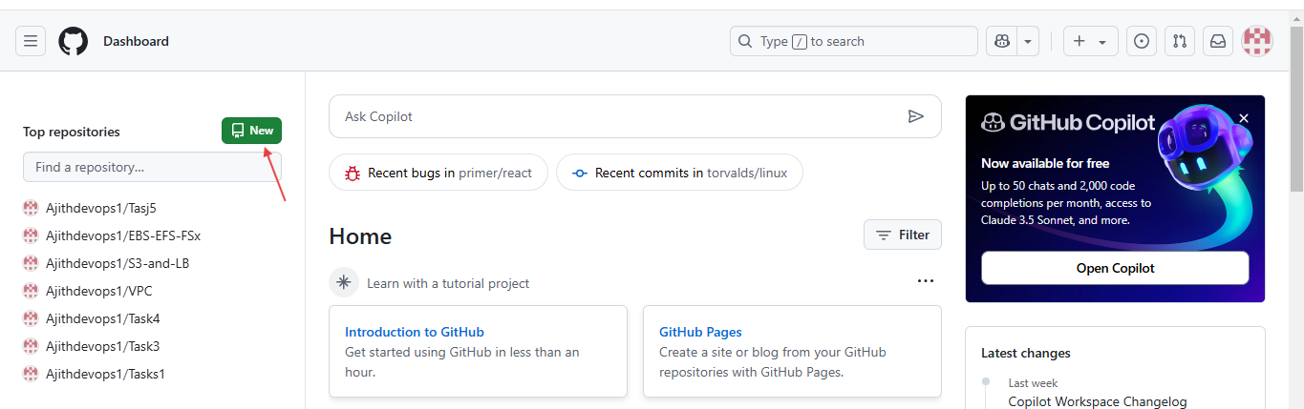

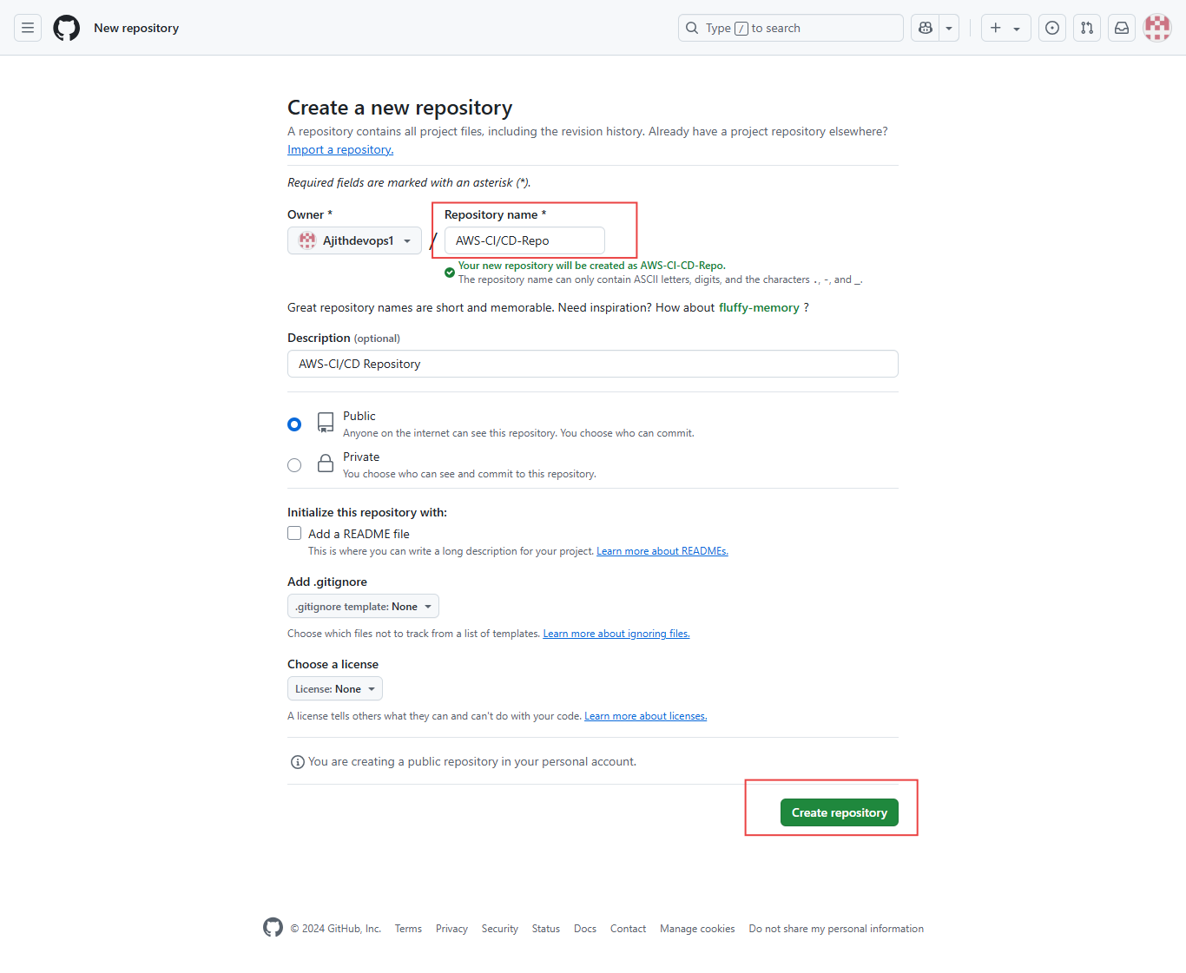

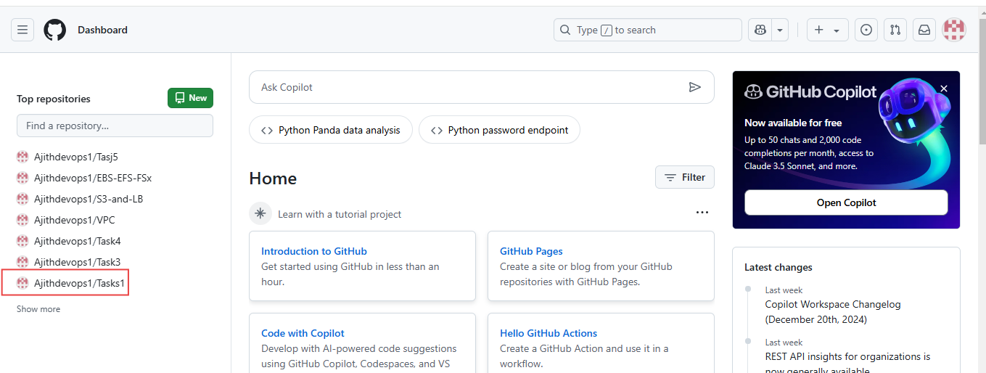

Copy to <https://github.com/Ajithdevops1/AWS-CI-CD-Repo.git> link and clone the path using visual studio code editor

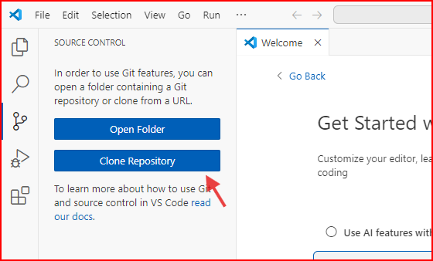

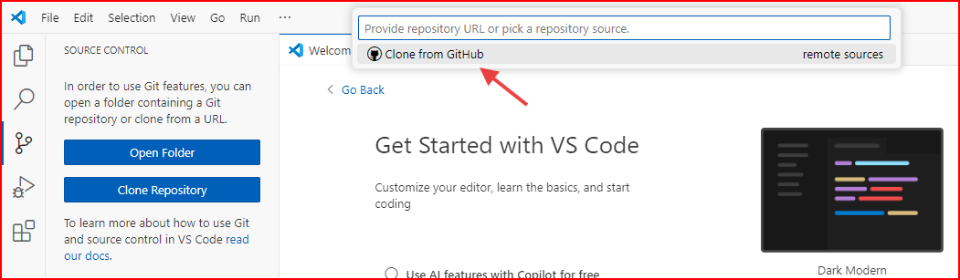

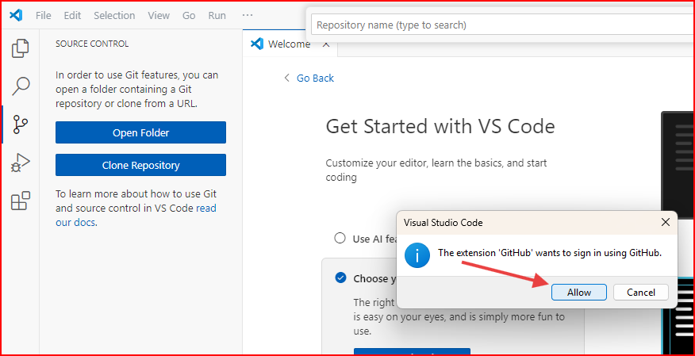

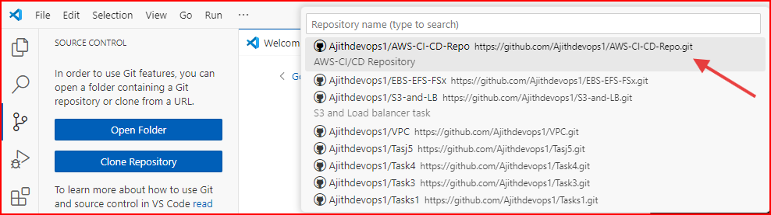

Crate new folder AWS-CI-CD-repo

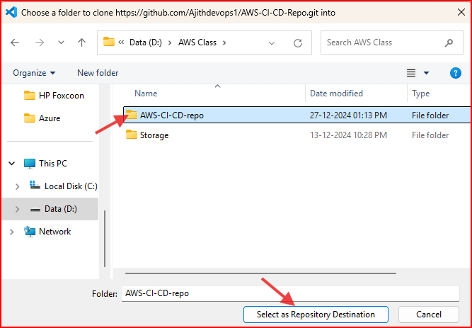

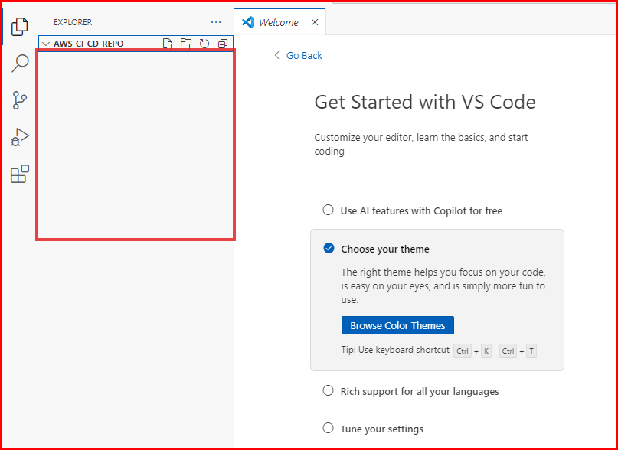

Create New folder inside app, scripts. Insied script folder crate install_dependencies.sh file

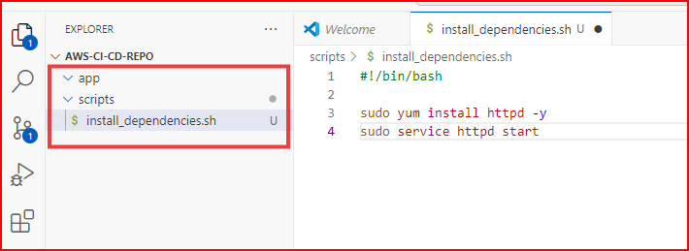

**Code: install_dependencies.sh**

#!/bin/bash

sudo yum install httpd -y

sudo service httpd start

**Code: appspec.yml**

version: 0.0

os: linux

files:

  - source: /app

    destination: /var/www/html

hooks:

  AfterInstall:

    - location: scripts/install_dependencies.sh

      timeout: 300

      runas: root

**Now add the html file in app folder**

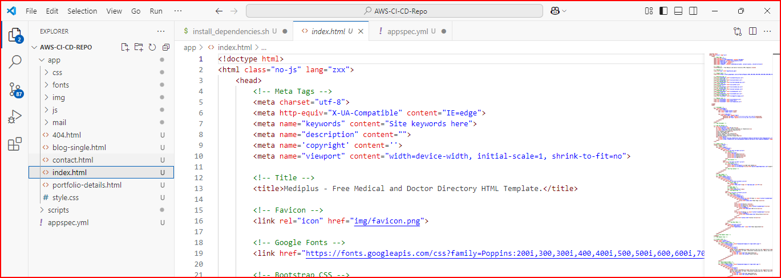

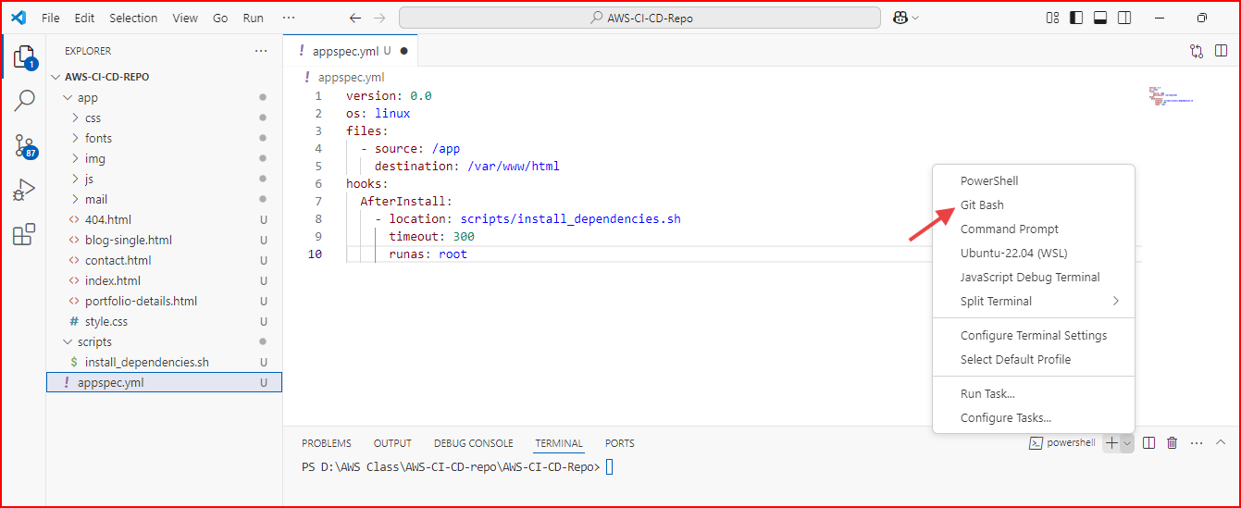

Now run command for git

**git add .**

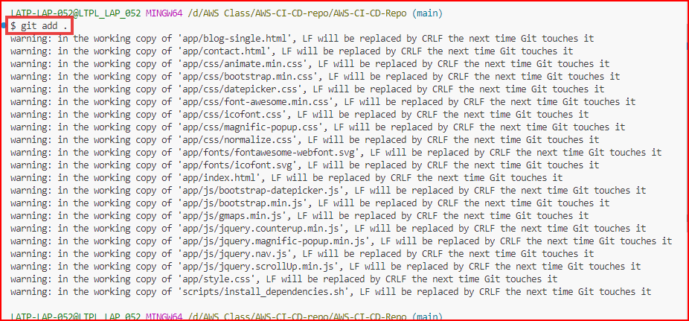

git config --global user.name "Ajith"

git config --global user.email "ajithdocgym@gmail.com"

**Verify the Configuration**

git config --global --list # For global settings

git config --list # For local settings in the current repository

**Commit command**

git commit -m "Added new files for CICD"

**OutPut**

LATP-LAP-052@LTPL_LAP_052 MINGW64 /d/AWS Class/AWS-CI-CD-repo/AWS-CI-CD-Repo (main)

$ **git config --global user.name "Ajith**"

LATP-LAP-052@LTPL_LAP_052 MINGW64 /d/AWS Class/AWS-CI-CD-repo/AWS-CI-CD-Repo (main)

$ **git config --global user.email "ajithdocgym@gmail.com"**

LATP-LAP-052@LTPL_LAP_052 MINGW64 /d/AWS Class/AWS-CI-CD-repo/AWS-CI-CD-Repo (main)

$ **git config --global --list**

user.name=Ajith

user.email=ajithdocgym@gmail.com

LATP-LAP-052@LTPL_LAP_052 MINGW64 /d/AWS Class/AWS-CI-CD-repo/AWS-CI-CD-Repo (main)

$ **git config --list**

diff.astextplain.textconv=astextplain

filter.lfs.clean=git-lfs clean -- %f

filter.lfs.smudge=git-lfs smudge -- %f

filter.lfs.process=git-lfs filter-process

filter.lfs.required=true

http.sslbackend=openssl

http.sslcainfo=C:/Program Files/Git/mingw64/etc/ssl/certs/ca-bundle.crt

core.autocrlf=true

core.fscache=true

core.symlinks=false

pull.rebase=false

credential.helper=manager

credential.https://dev.azure.com.usehttppath=true

init.defaultbranch=master

user.name=Ajith

user.email=ajithdocgym@gmail.com

core.repositoryformatversion=0

core.filemode=false

core.bare=false

core.logallrefupdates=true

core.symlinks=false

core.ignorecase=true

remote.origin.url=https://github.com/Ajithdevops1/AWS-CI-CD-Repo.git

remote.origin.fetch=+refs/heads/*:refs/remotes/origin/*

branch.main.remote=origin

branch.main.merge=refs/heads/main

LATP-LAP-052@LTPL_LAP_052 MINGW64 /d/AWS Class/AWS-CI-CD-repo/AWS-CI-CD-Repo (main)

**$ git commit -m "Added new files for CICD"**

[main (root-commit) 5459a04] Added new files for CICD

87 files changed, 28105 insertions(+)

create mode 100644 app/404.html

create mode 100644 app/blog-single.html

create mode 100644 app/contact.html

create mode 100644 app/css/animate.min.css

create mode 100644 app/css/bootstrap.min.css

create mode 100644 app/css/datepicker.css

create mode 100644 app/css/font-awesome.min.css

create mode 100644 app/css/icofont.css

create mode 100644 app/css/magnific-popup.css

create mode 100644 app/css/nice-select.css

create mode 100644 app/css/normalize.css

create mode 100644 app/css/owl-carousel.css

create mode 100644 app/css/responsive.css

create mode 100644 app/css/slicknav.min.css

create mode 100644 app/fonts/fontawesome-webfont.eot

create mode 100644 app/fonts/fontawesome-webfont.svg

create mode 100644 app/fonts/fontawesome-webfont.ttf

create mode 100644 app/fonts/fontawesome-webfont.woff

create mode 100644 app/fonts/fontawesome-webfont.woff2

create mode 100644 app/fonts/icofont.eot

create mode 100644 app/fonts/icofont.svg

create mode 100644 app/fonts/icofont.ttf

create mode 100644 app/fonts/icofont.woff

create mode 100644 app/fonts/icofont.woff2

create mode 100644 app/img/about-img.jpg

create mode 100644 app/img/author1.jpg

create mode 100644 app/img/author2.jpg

create mode 100644 app/img/author3.jpg

create mode 100644 app/img/blockqoute-bg.jpg

create mode 100644 app/img/blog-sidebar1.jpg

create mode 100644 app/img/blog-sidebar2.jpg

create mode 100644 app/img/blog-sidebar3.jpg

create mode 100644 app/img/blog1.jpg

create mode 100644 app/img/blog2.jpg

create mode 100644 app/img/blog3.jpg

create mode 100644 app/img/bread-bg.jpg

create mode 100644 app/img/call-bg.jpg

create mode 100644 app/img/client-bg.jpg

create mode 100644 app/img/client1.png

create mode 100644 app/img/client2.png

create mode 100644 app/img/client3.png

create mode 100644 app/img/client4.png

create mode 100644 app/img/client5.png

create mode 100644 app/img/contact-img.png

create mode 100644 app/img/favicon.png

create mode 100644 app/img/fun-bg.jpg

create mode 100644 app/img/logo.png

create mode 100644 app/img/map-marker.png

create mode 100644 app/img/mission-img.jpg

create mode 100644 app/img/pf1.jpg

create mode 100644 app/img/pf2.jpg

create mode 100644 app/img/pf3.jpg

create mode 100644 app/img/pf4.jpg

create mode 100644 app/img/section-img.png

create mode 100644 app/img/signup-bg.jpg

create mode 100644 app/img/slider.jpg

create mode 100644 app/img/slider2.jpg

create mode 100644 app/img/slider3.jpg

create mode 100644 app/img/testi-bg.jpg

create mode 100644 app/img/video-bg.jpg

create mode 100644 app/index.html

create mode 100644 app/js/bootstrap-datepicker.js

create mode 100644 app/js/bootstrap.min.js

create mode 100644 app/js/colors.js

create mode 100644 app/js/easing.js

create mode 100644 app/js/gmaps.min.js

create mode 100644 app/js/jquery-migrate-3.0.0.js

create mode 100644 app/js/jquery-ui.min.js

create mode 100644 app/js/jquery.counterup.min.js

create mode 100644 app/js/jquery.magnific-popup.min.js

create mode 100644 app/js/jquery.min.js

create mode 100644 app/js/jquery.nav.js

create mode 100644 app/js/jquery.scrollUp.min.js

create mode 100644 app/js/main.js

create mode 100644 app/js/map-active.js

create mode 100644 app/js/niceselect.js

create mode 100644 app/js/owl-carousel.js

create mode 100644 app/js/popper.min.js

create mode 100644 app/js/slicknav.min.js

create mode 100644 app/js/steller.js

create mode 100644 app/js/tilt.jquery.min.js

create mode 100644 app/js/wow.min.js

create mode 100644 app/mail/mail.php

create mode 100644 app/portfolio-details.html

create mode 100644 app/style.css

create mode 100644 appspec.yml

create mode 100644 scripts/install_dependencies.sh

LATP-LAP-052@LTPL_LAP_052 MINGW64 /d/AWS Class/AWS-CI-CD-repo/AWS-CI-CD-Repo (main)

$ **git push**

Enumerating objects: 96, done.

Counting objects: 100% (96/96), done.

Delta compression using up to 8 threads

Compressing objects: 100% (94/94), done.

Writing objects: 100% (96/96), 4.89 MiB | 2.04 MiB/s, done.

Total 96 (delta 5), reused 0 (delta 0), pack-reused 0 (from 0)

remote: Resolving deltas: 100% (5/5), done.

**To https://github.com/Ajithdevops1/AWS-CI-CD-Repo.git**

* [new branch] main -> main

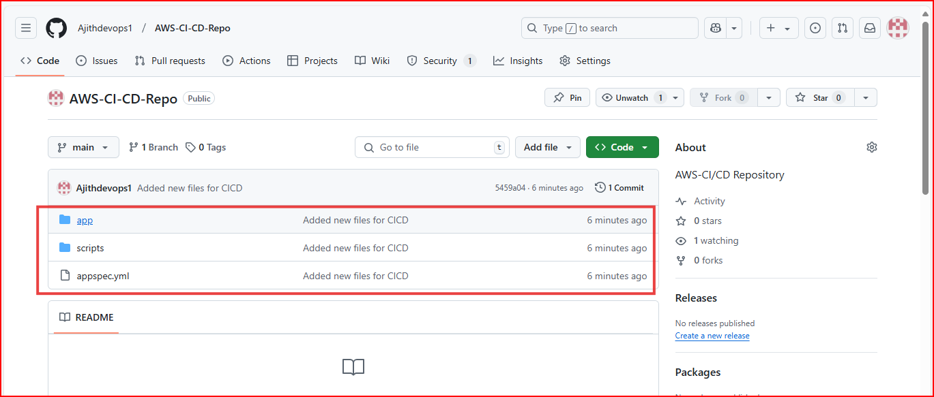

**Now go to codedeploy in AWS**

**Create a Code Deploy and Deployment Group**

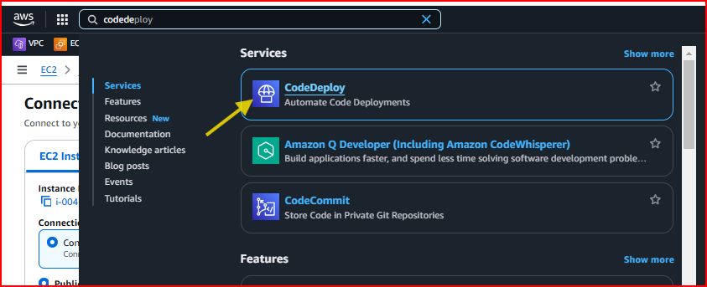

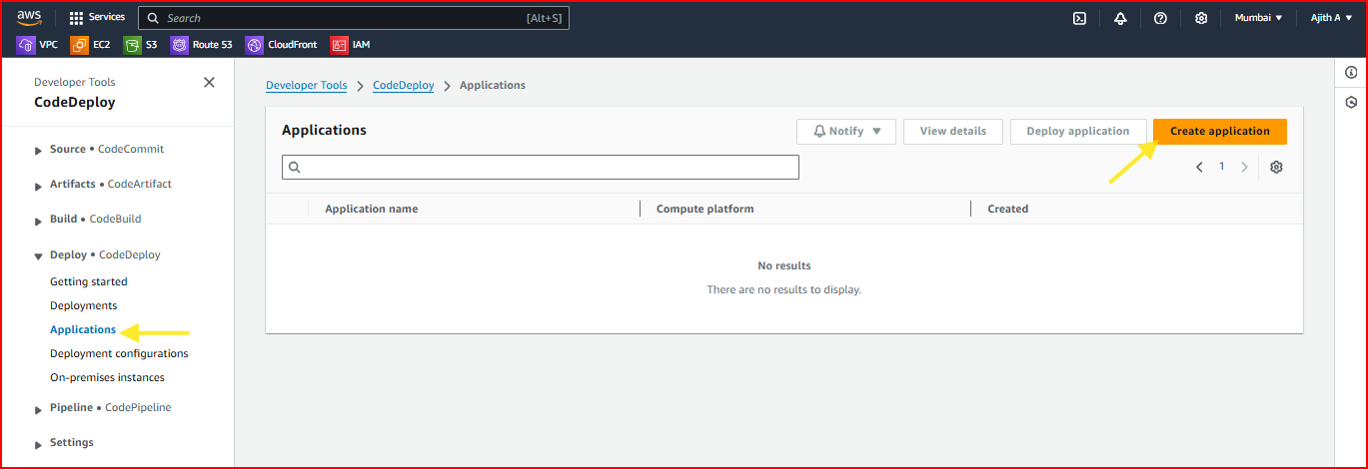

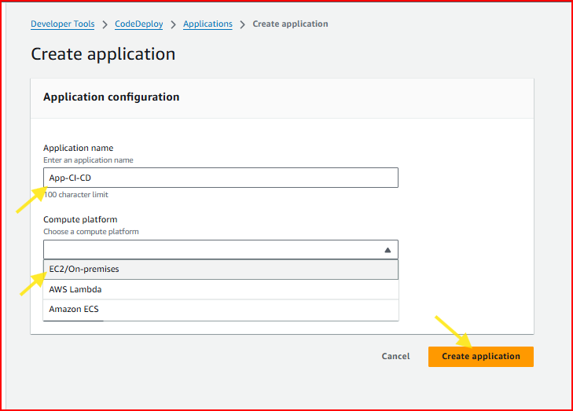

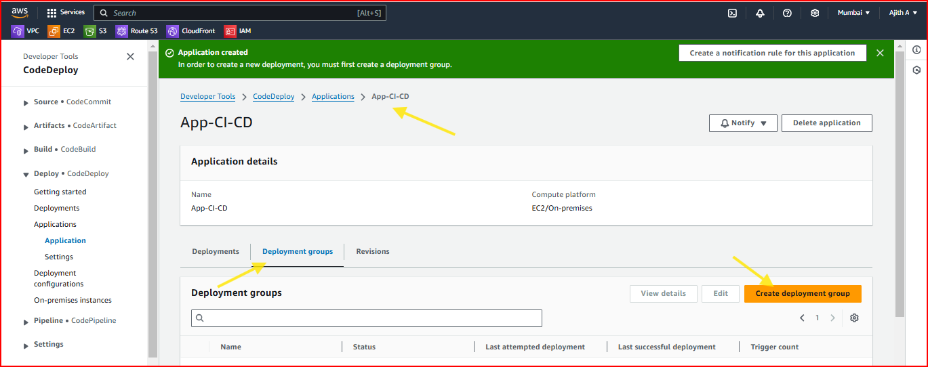

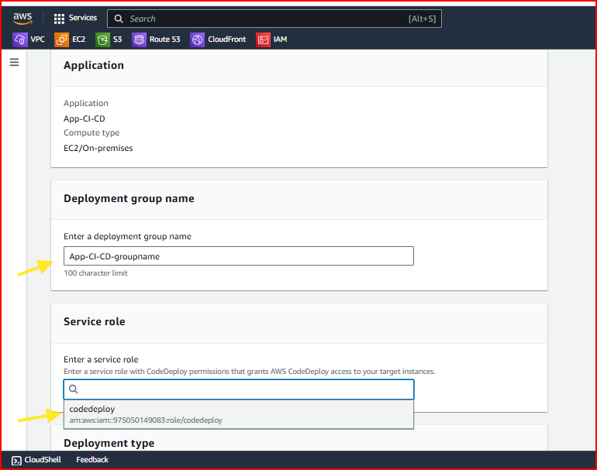

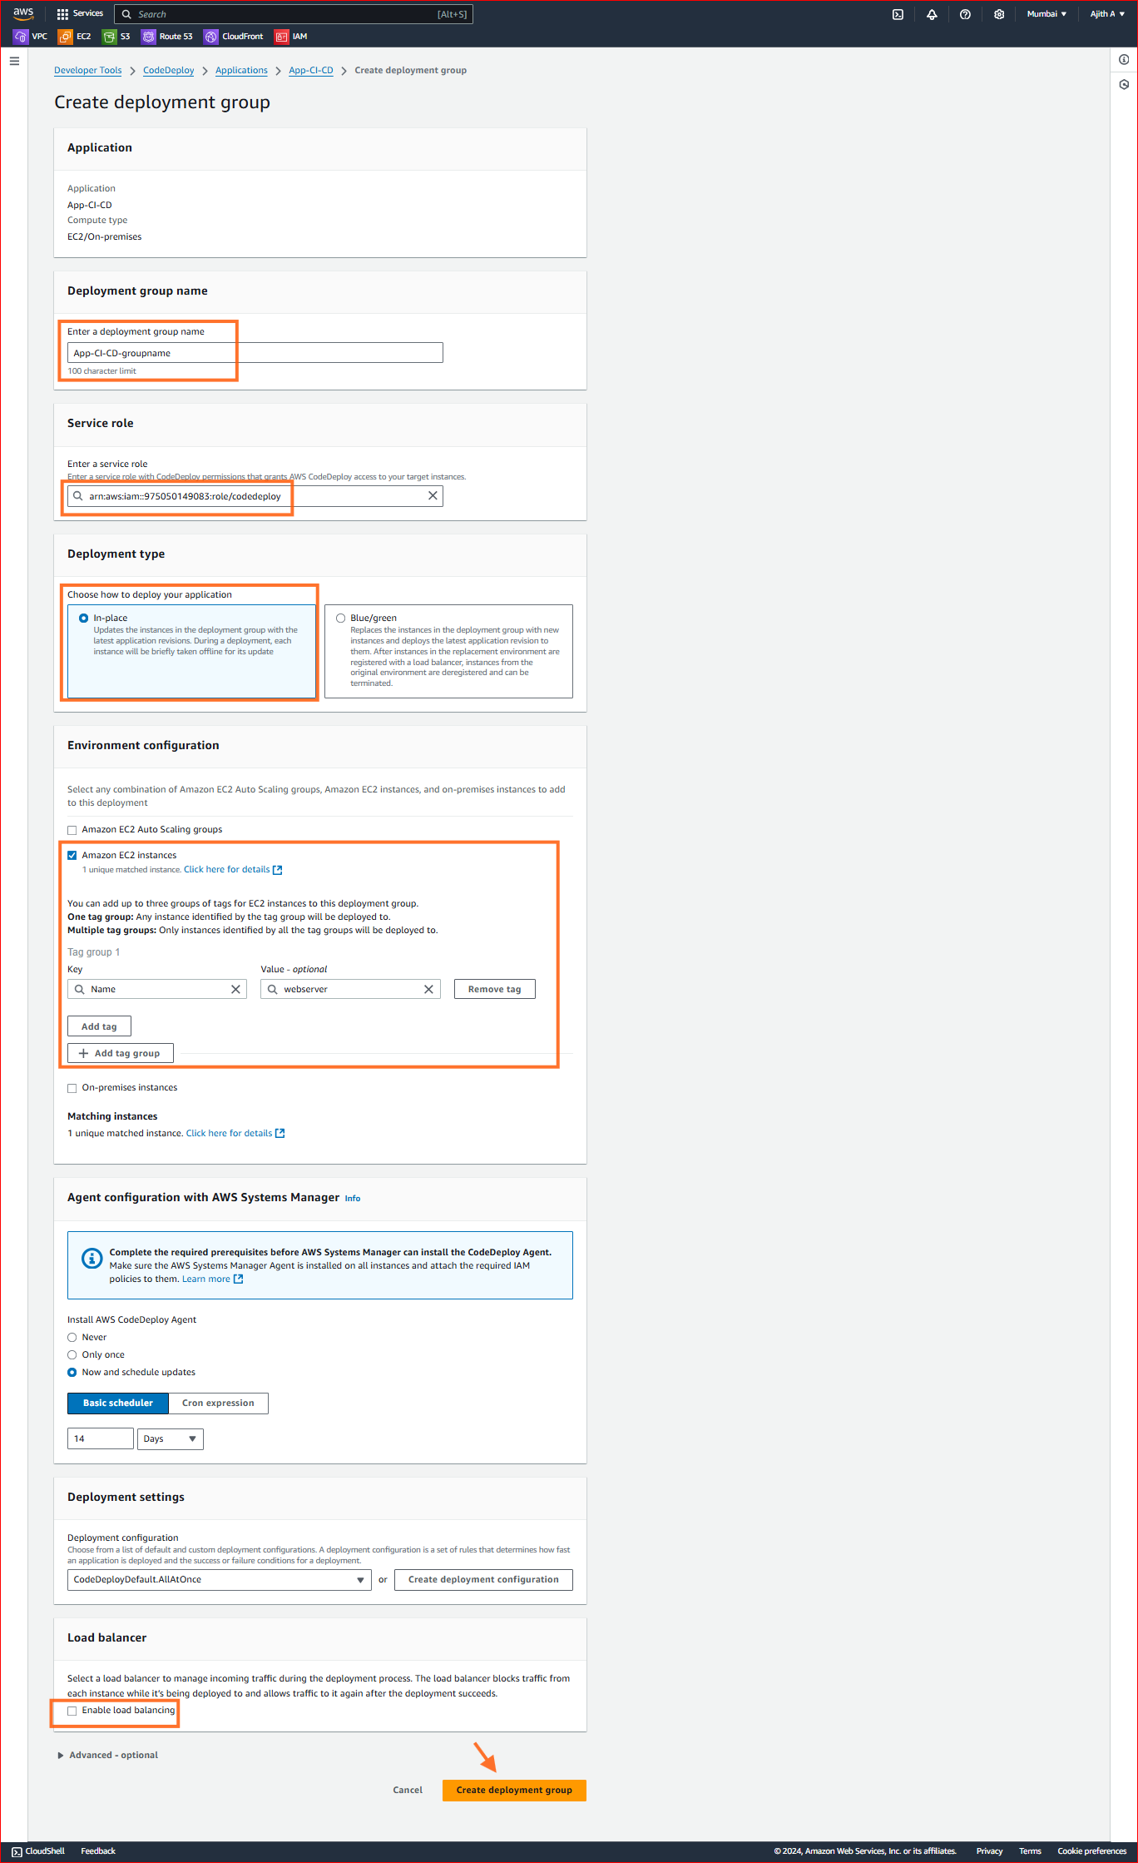

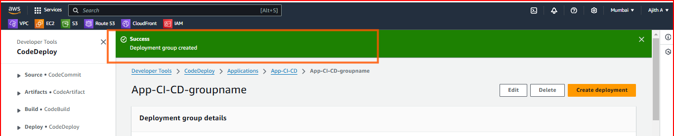

**Next crate Pipelines**

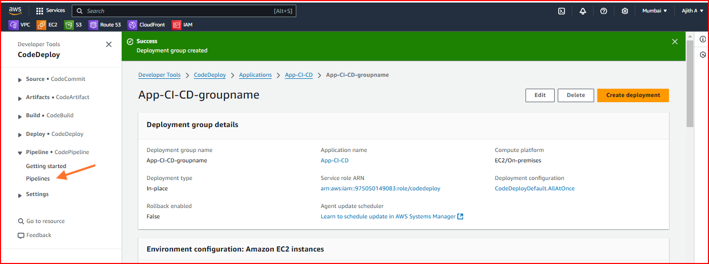

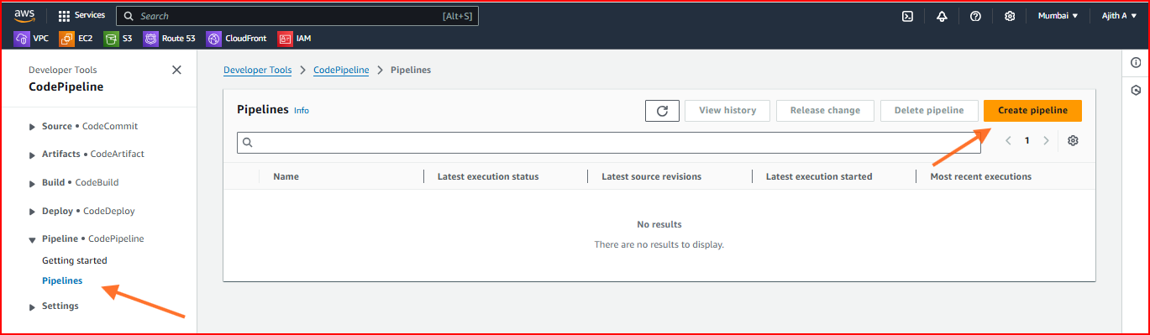

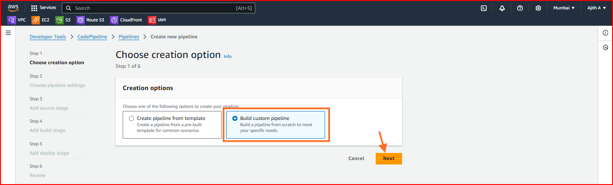

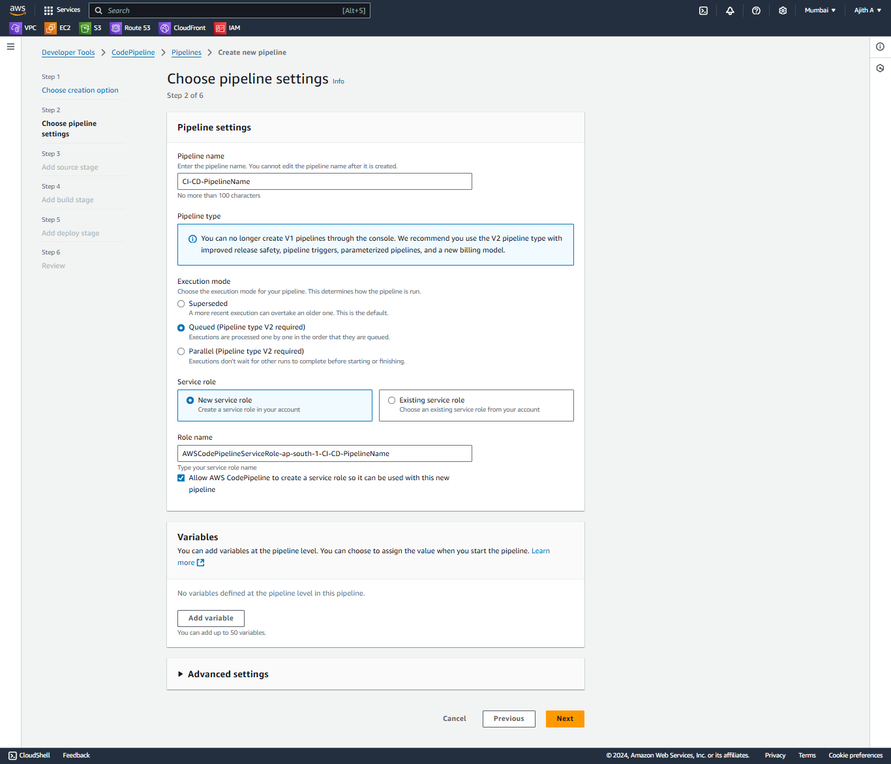

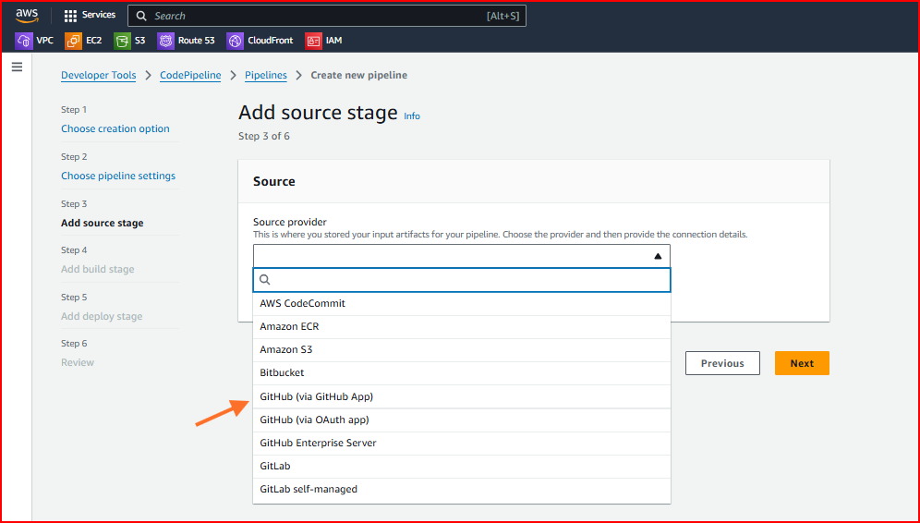

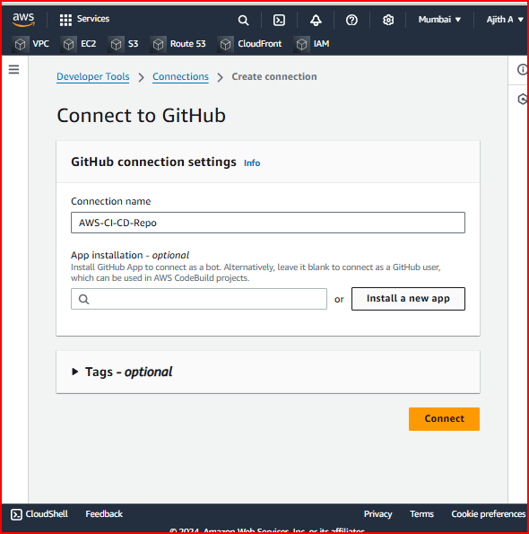

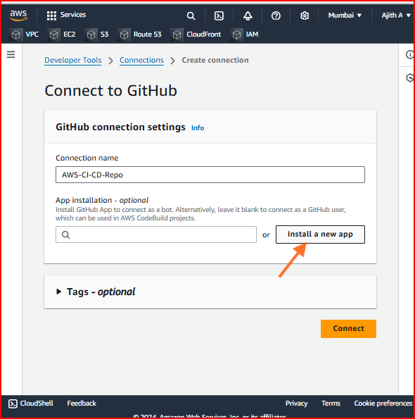

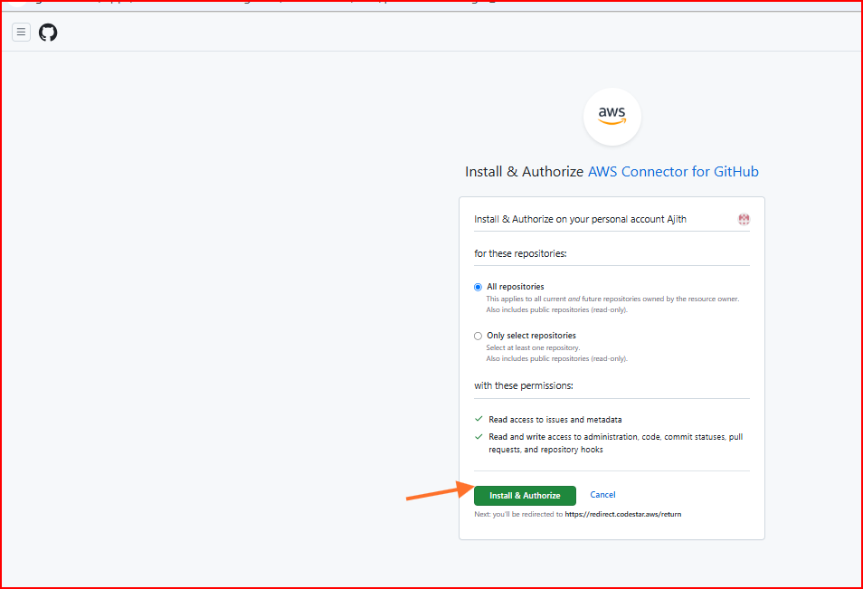

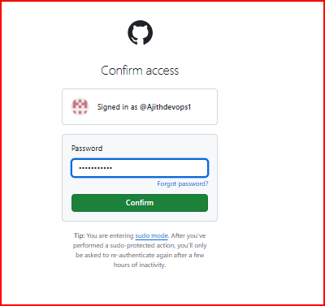

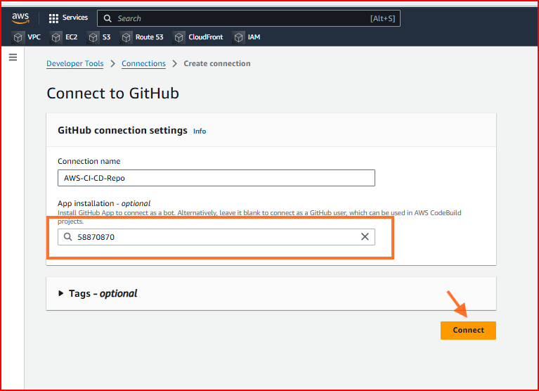

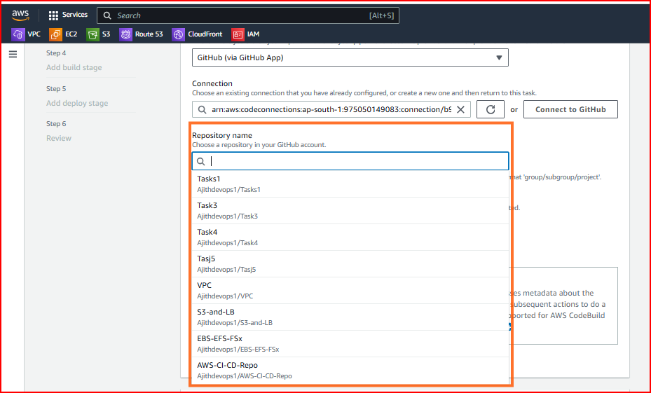

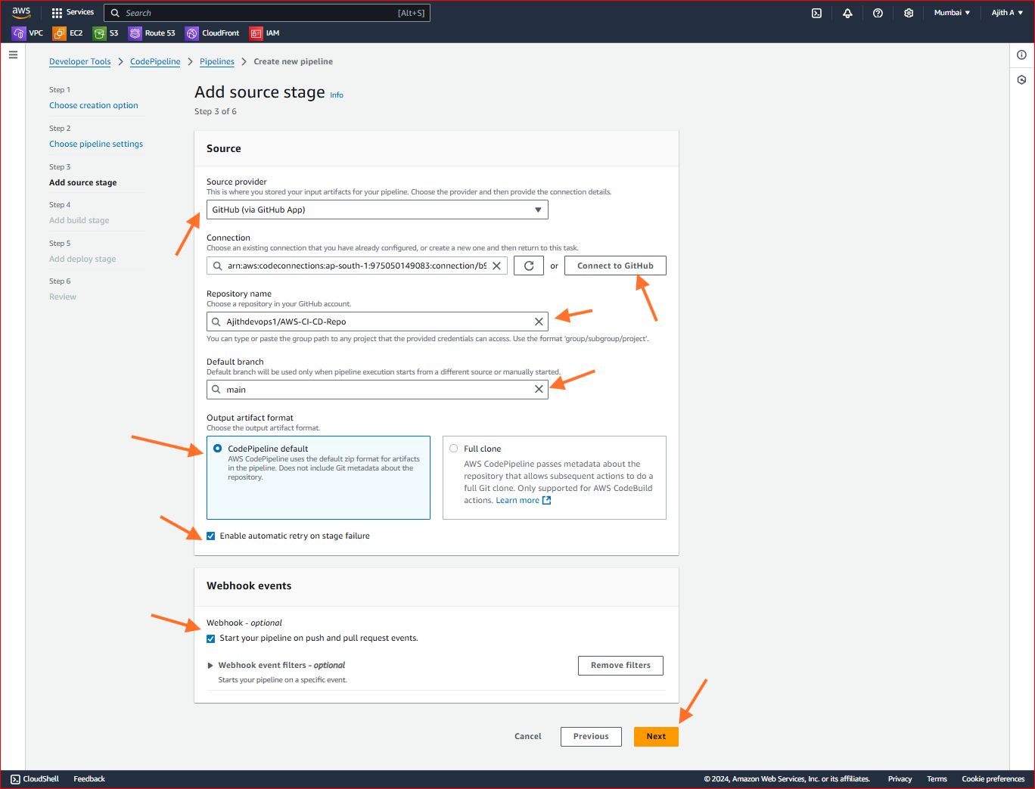

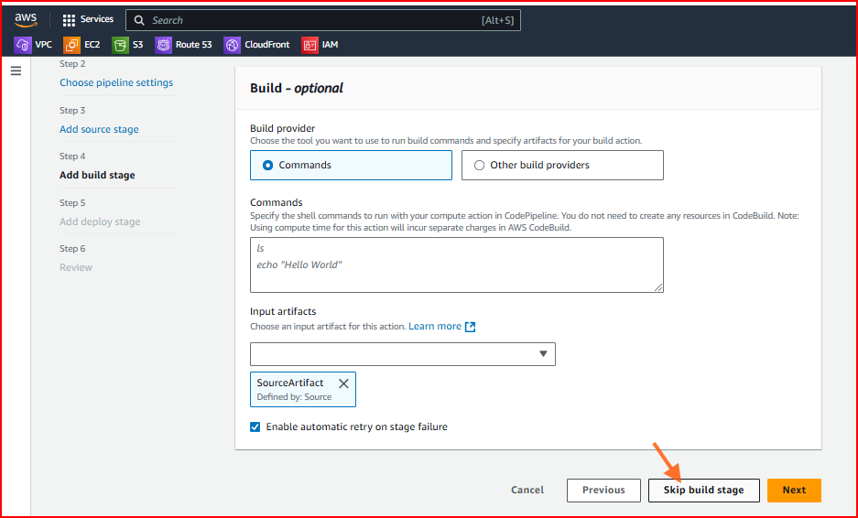

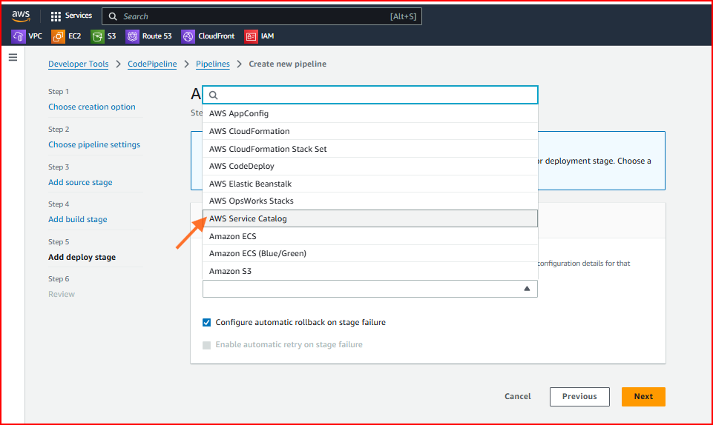

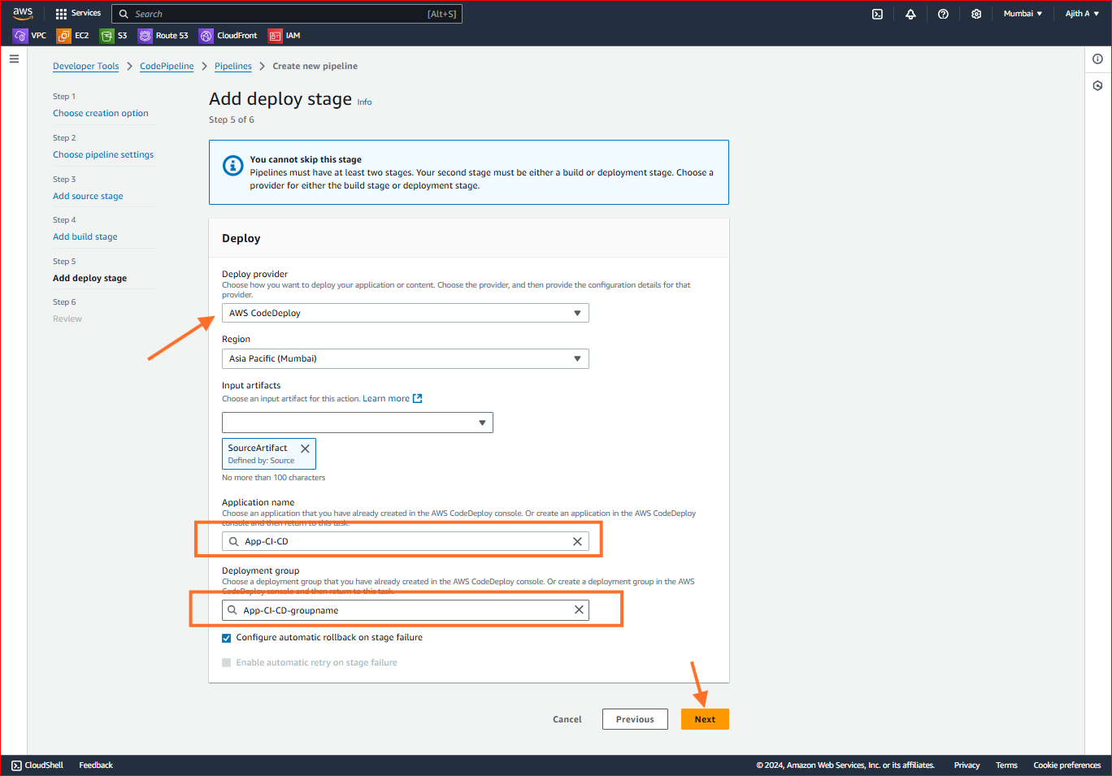

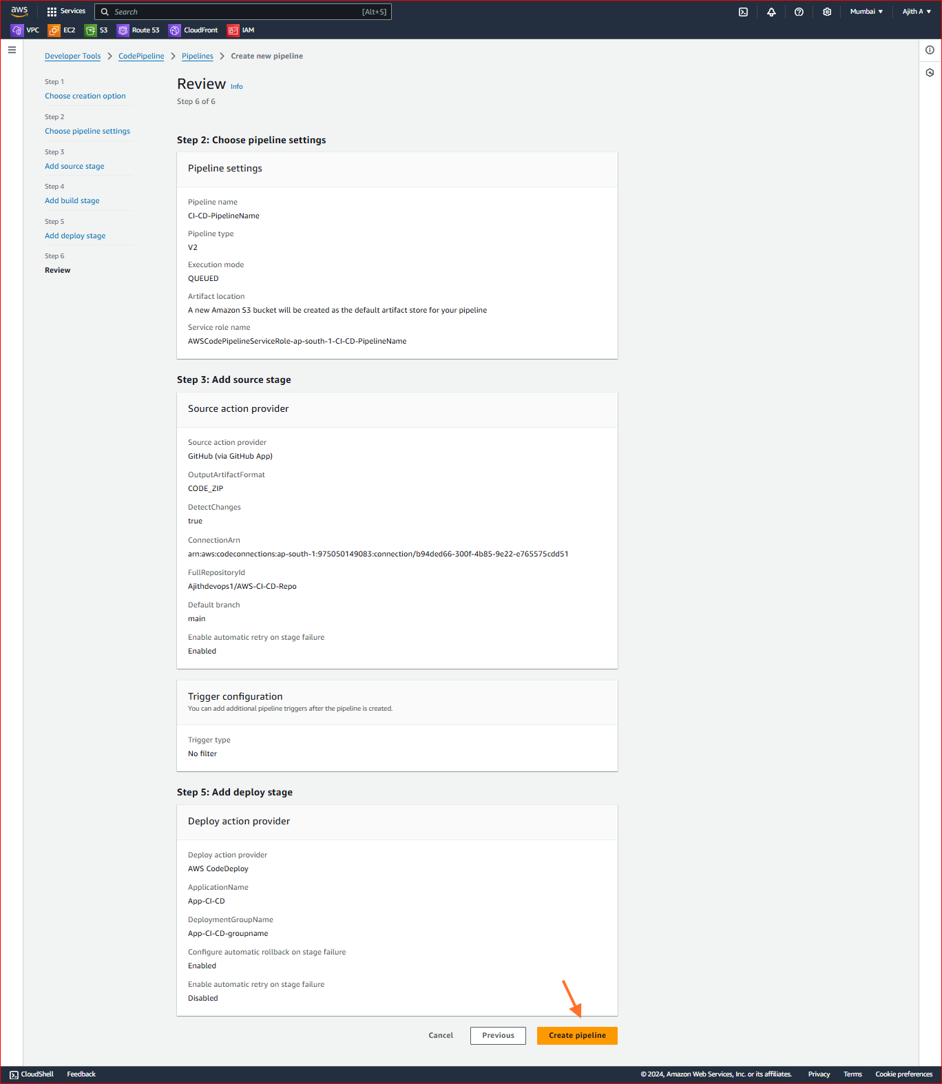

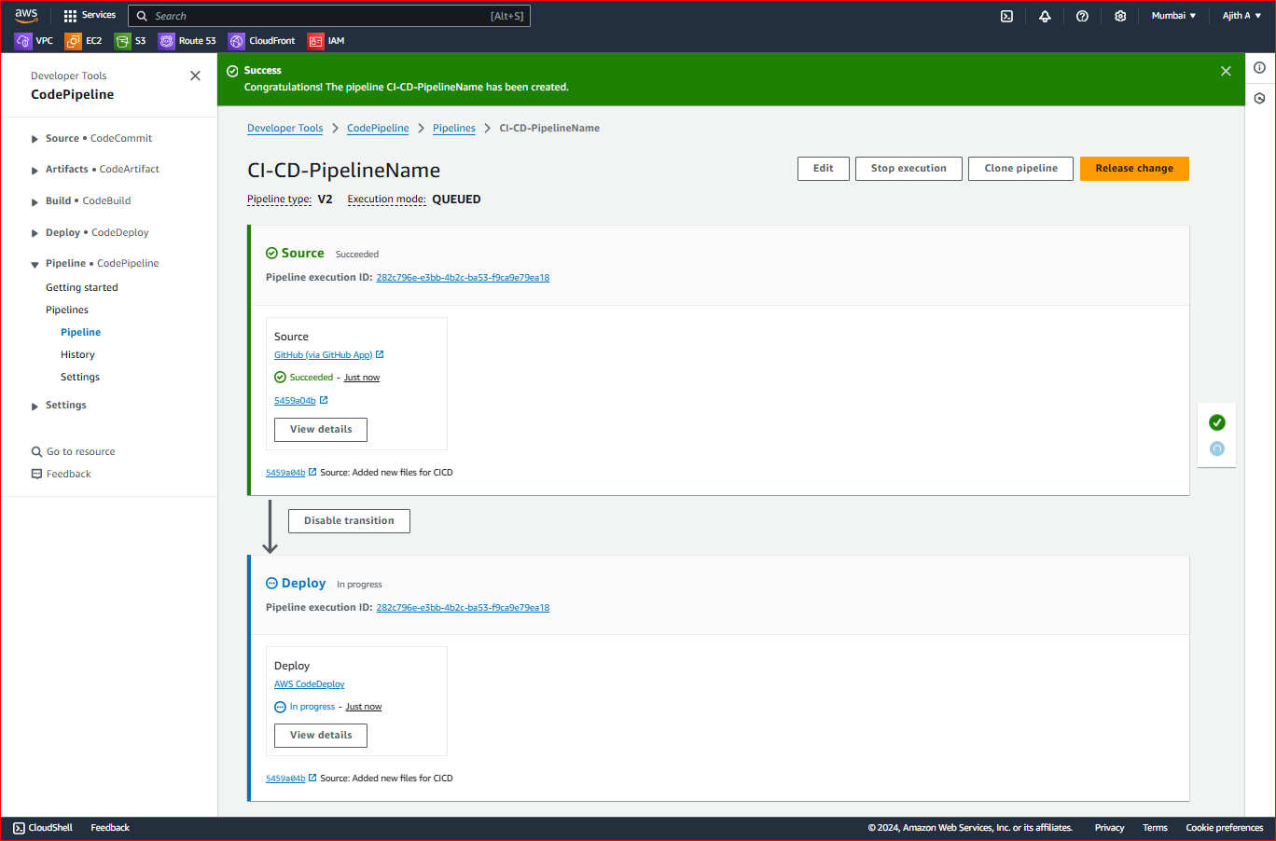

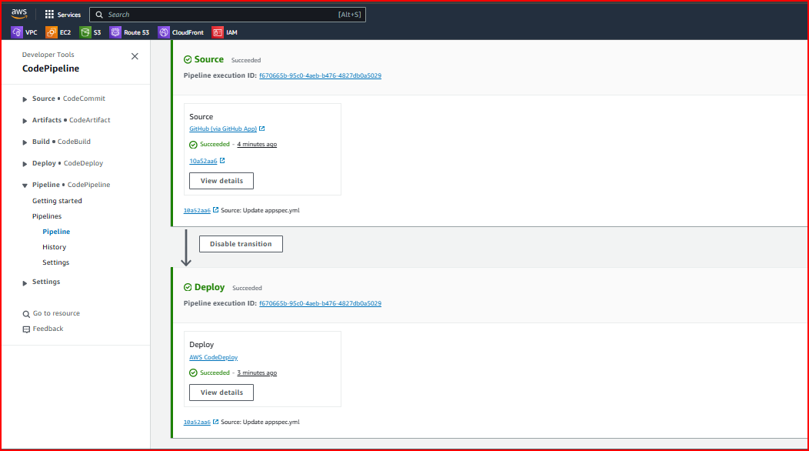

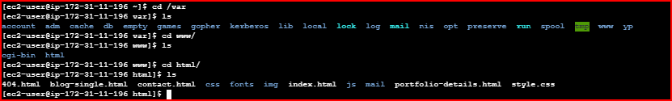



Before Change Code

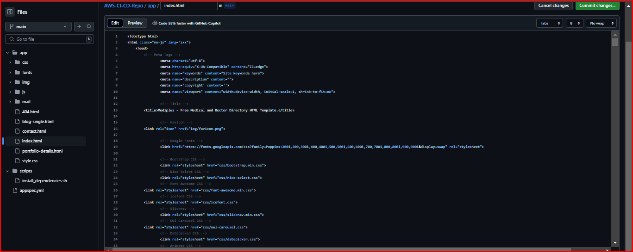

After change code

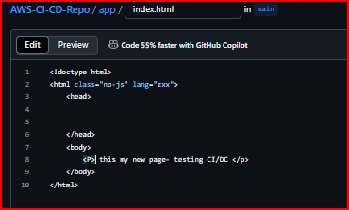

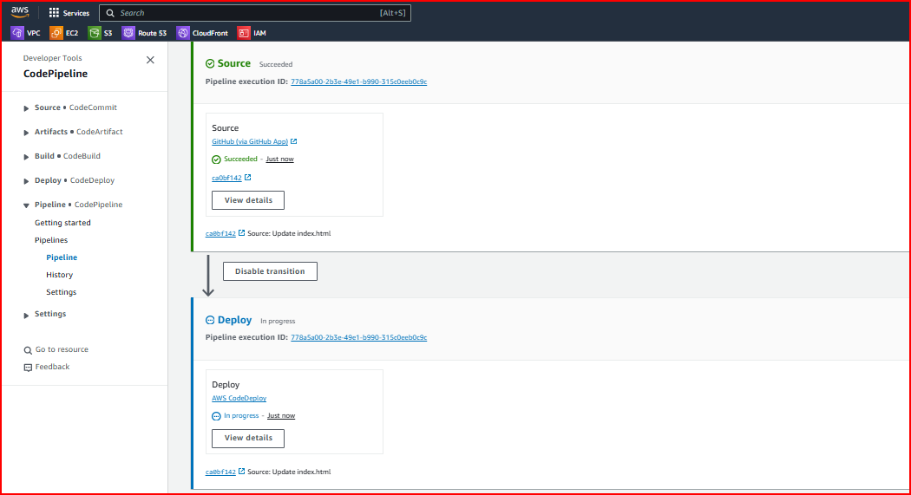

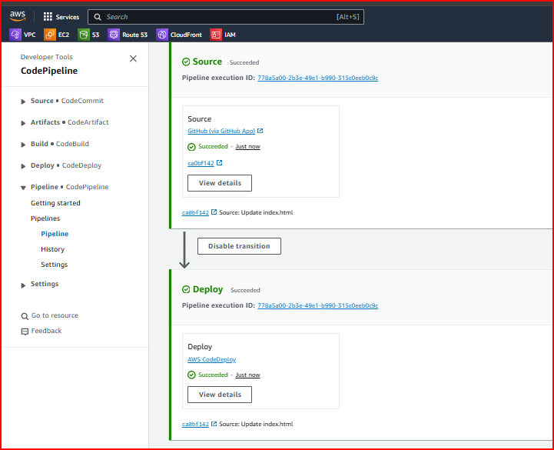

Output:

